SUBCOURSE EDITION
OD0479 8

PRINCIPLES AND TROUBLESHOOTING OF THE
SUSPENSION SYSTEM - M1 TANK



PRINCIPLES AND TROUBLESHOOTING OF
THE SUSPENSION SYSTEM – M1 TANK

SUBCOURSE NO. OD0479

US Army Correspondence
Course Program

5 Credit Hours
NEW: 1988

GENERAL

The purpose of this subcourse is to introduce the suspension system on the MI tank. Emphasis will be placed on the principles of operation, components, and the procedures for troubleshooting the suspension system on this vehicle.

Five credit hours are awarded for successful completion of this subcourse.

Lesson 1: PRINCIPLES OF OPERATION AND COMPONENTS OF THE SUSPENSION SYSTEM ON THE M1 TANK.

TASK 1: Describe the principles of operation and components of the suspension system.

Lesson 2: PROCEDURES FOR TROUBLESHOOTING THE SUSPENSION SYSTEM ON THE MI TANK.

TASK 1: Describe the procedures for troubleshooting the suspension system.

i
PRIN. & T/S OF SUSPEN. SYS M1 – OD0479

TABLE OF CONTENTS

Section Page

TITLE i

TABLE OF CONTENTS ii

Lesson 1: PRINCIPLES OF OPERATION AND
COMPONENTS OF THE SUSPENSION SYSTEM
ON THE M1 TANK 1

Task 1: Describe the principles of
operation and components of the
suspension system 1

Practical Exercise 1 21

Answers to Practical Exercise 1 23

Lesson 2: PROCEDURES FOR TROUBLESHOOTING THE
SUSPENSION SYSTEM ON THE Ml TANK 24

Task 1: Describe the procedures for
troubleshooting the suspension system 24

Practical Exercise 2 49

Answers to Practical Exercise 2 50

REFERENCES 51

ii
PRIN. & T/S OF SUSPEN. SYS M1 - OD0479 - LESSON 1/TASK 1

LESSON 1

PRINCIPLES OF OPERATION AND COMPONENTS
OF THE SUSPENSION SYSTEM ON THE M1 TANK

TASK 1. Describe the principles of operation and
components of the suspension system.

CONDITIONS

Within a self-study environment and given the
subcourse text, without assistance.

STANDARDS

Within 2 hours

REFERENCES

No supplementary references are needed for this
task.

1. Introduction

The suspension system's main purpose is to support the weight of the vehicle. The M1 tank, which is very heavy and must be able to cross all types of terrain, depends heavily on the suspension system. The suspension system must support the vehicle so that the immense weight will not cause it to sink, even in soft ground.

This task will describe the principles of operation, the components, and the preventive maintenance checks and services (PMCS) on the suspension system of the Ml tank.

As in any other system on the M1 tank, the suspension system is vital td the operation of the vehicle. When the system malfunctions, in order to repair it, the mechanic must have a thorough knowledge of the system.

1
PRIN. & T/S OF SUSPEN. SYS M1 - OD0479 - LESSON 1/TASK 1

2. Principles of Operation

a. General Functions. The track and suspension are the final elements in the mobility of the M1 tank. They fulfill three general functions: (1) lay a roadbed and move the tank in the process, (2) support the weight and absorb shock loads, and (3) provide a smooth ride.

b. Sub-Assemblies. The M1 tank's suspension system (figure 1) is a hydromechanical system which provides static and dynamic support for the vehicle through torsion bars, and dampening of terrain-induced vehicle oscillation by rotary hydraulic shock absorbers. Each side of the vehicle contains the following major sub-assemblies; compensating idler with track adjusting link, seven roadarm stations with dual roadwheels, two single-wheel track support rollers, drive hub and dual sprockets, rotary shock absorbers, bump stops at wheel stations 1, 2, and 7; and a 25 inch wide double-pin, rubber-bushed integral pad track.
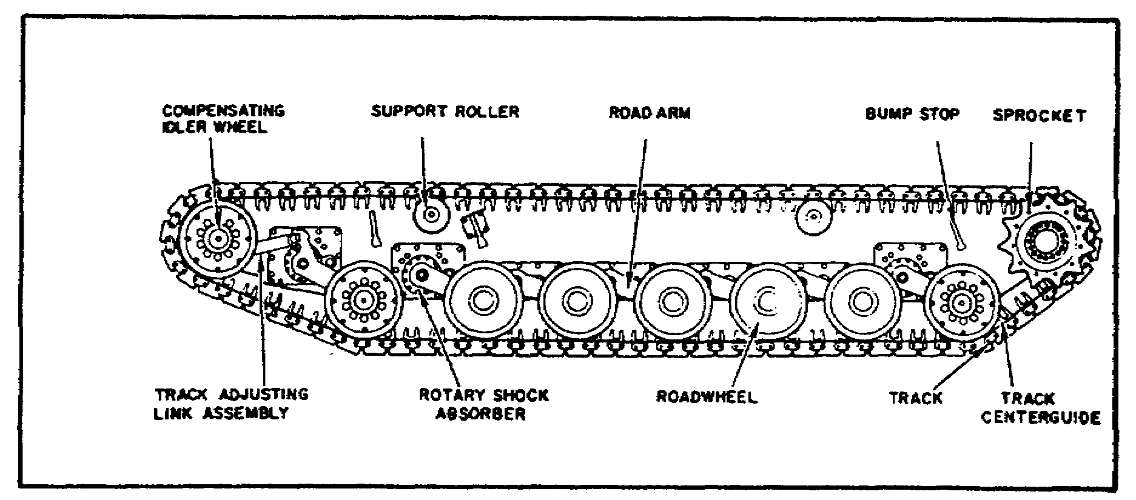
FIGURE 1. M1 SUSPENSION SYSTEM.

c. Track Drive. The compensating idlers and track adjusting linkages are installed at the front of the tank, and are connected to the first roadarms. Track drive is effected through the sprockets and hubs, which are attached to the final drive assemblies at the rear of the tank.

The track is supported and aligned between the drive sprocket and compensating idler wheel by two track support rollers.

2
PRIN. & T/S OF SUSPEN. SYS M1 - OD0479 - LESSON 1/TASK 1

d. Torsion Bars. Each roadarm attaches to a housing assembly, which is bolted to the hull. The weight of the vehicle, resting on the track and roadwheel, moves the roadarm upward, producing a rotational movement in the upper spindle which twists the torsion bars. As shifting vehicle weight moves each roadarm upward, the twisting action of the torsion bars resists the motion, producing a springing action which supports the load and keeps the track in contact with the ground.

Roadwheel positions are identified by numbers 1 through 7, starting with number 1 at the front of the tank and going to number 7 at the rear.

3. Characteristics

The M1 tank suspension system characteristics are shown in table 1.

TABLE 1. SUSPENSION CHARACTERISTICS.

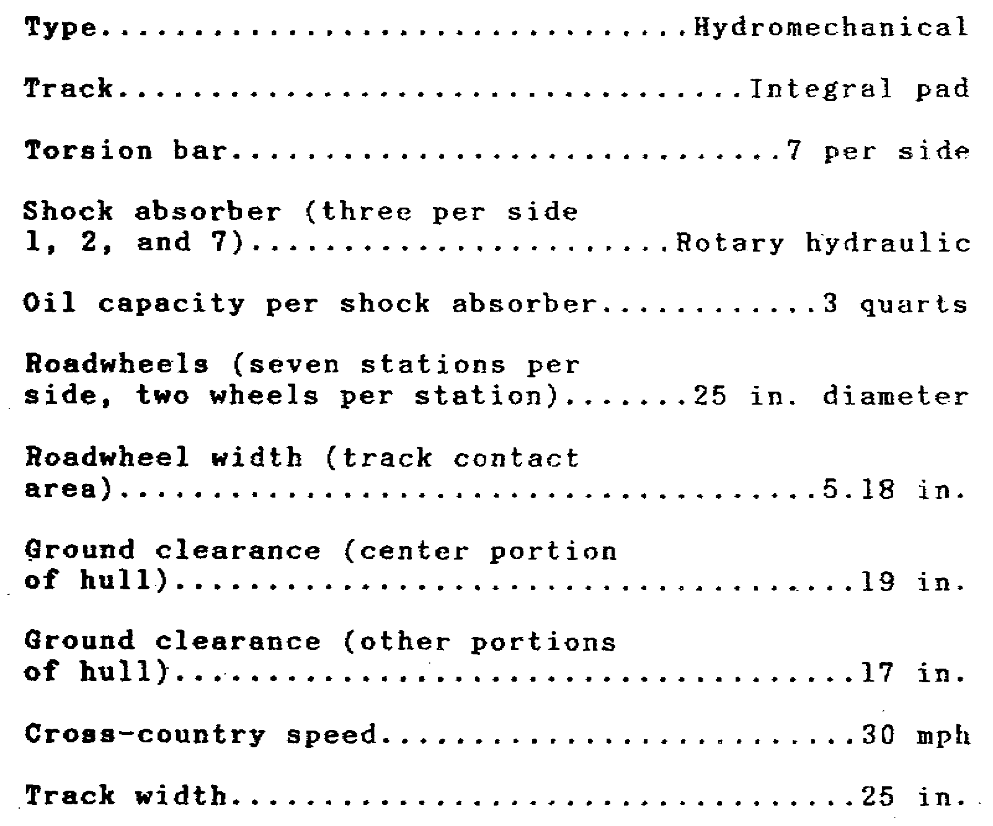

3
PRIN. & T/S OF SUSPEN. SYS M1 - OD0479 - LESSON 1/TASK 1

TABLE 1. SUSPENSION CHARACTERISTICS (CONTINUED).

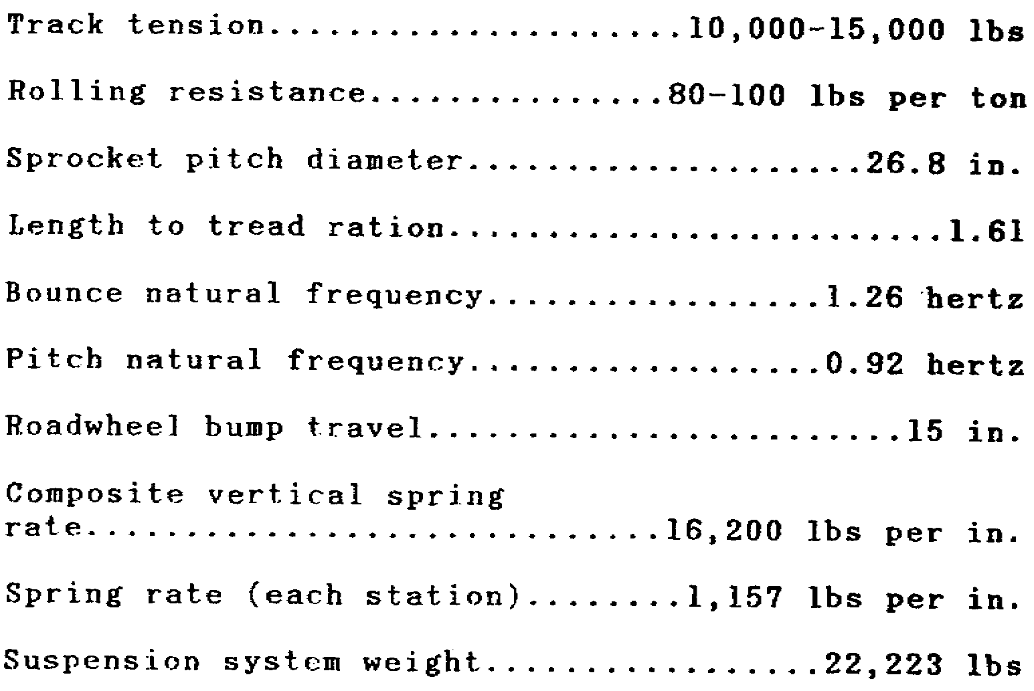

4. Components

a. Torsion Bars. The M1 tank suspension system consists of 14 high-hardness steel torsion bars and 14 protective covers, sealed by integral retainers. Figure 2, on the following page, illustrates a typical assembly configuration. The aluminum tubular cover protects the torsion bar and spline areas from bilge contamination and, because of the mechanical protection, eliminates the need for the usual protective tape wrapping found on torsion bars in other vehicles. The torsion bars are corrosion-protected with a polyurethane varnish coating, and the splines are covered with grease before installation. The system is designed to permit exterior access to the torsion bars from both sides of the tank. Therefore, if a torsion bar breaks, each broken end of the bar can be pulled out. If there are any fragments, they will be contained in the aluminum cover tube from which they can be removed from outside the tank.

4
PRIN. & T/S OF SUSPEN. SYS M1 -OD 0479 -LESSON 1/TASK 1

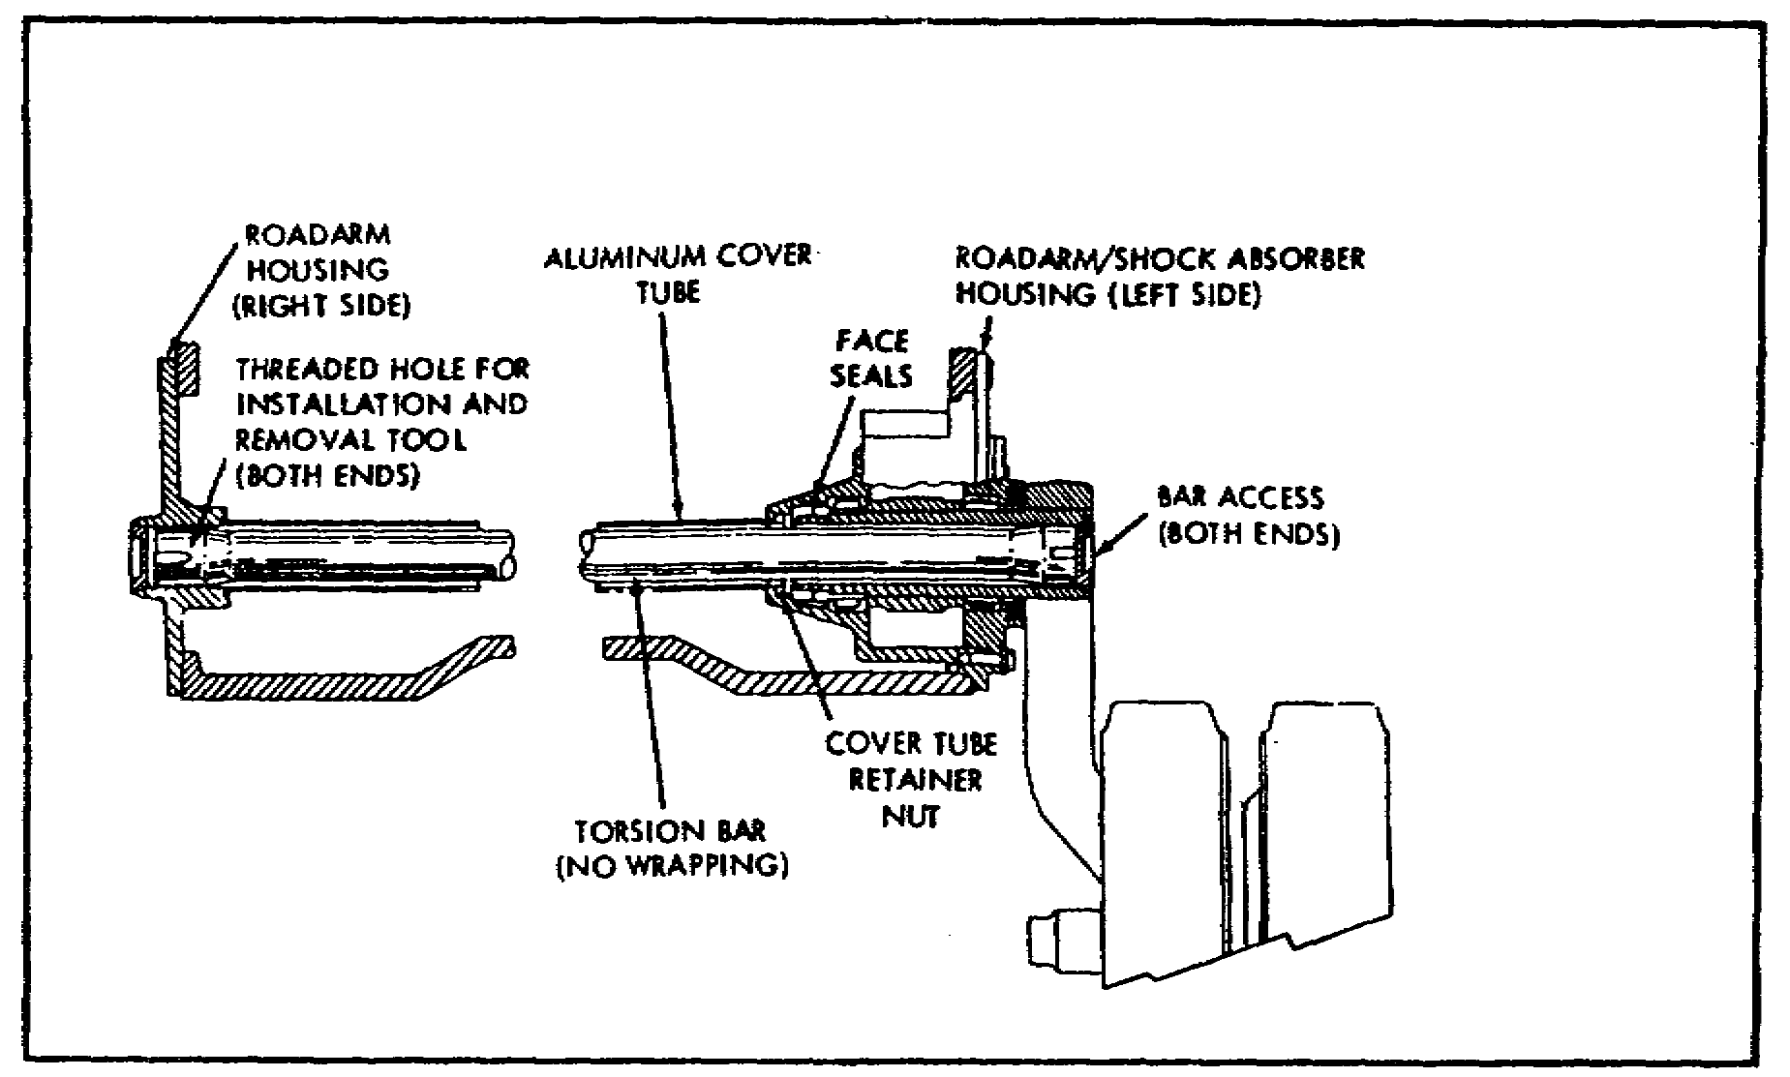
FIGURE 2. TYPICAL ASSEMBLY CONFIGURATION
FOR ONE SPRING.

b. Shock Absorbers. The modular rotary hydraulic shock absorber (figure 3 on the following page) consists of two major elements: a rotor with two vanes, housing damping valves and seals, and a stator, with vanes and seals. The rotor is actuated by splines located on the roadarm spindle; the stator is held stationary by a key that reacts against the suspension housing. End plates are secured to the shock absorber with four screws and, after installation, the shock absorber is held in place by the clamping force provided by the roadarm retainers.

Installation and removal of the shock assembly requires no tools, once it has been exposed by removal of the roadarm assemblies. Damping characteristics are controlled by four jounce valves and two rebound valves (all relief type valves). The relief valves consist of cartridge assemblies, set for proper cracking pressure before installation into the rotor. Each cartridge assembly is threaded into the rotor vane, achieving cartridge sealing and locking in place by means of pipe threads.

Shock absorber sealing is achieved by polyimide vane and end-plate seals, all of which are actuated by the shock absorber oil pressure. Rotary hydraulic shock absorbers (a total of six) are

5
PRIN. & T/S OF SUSPEN. SYS M1 - OD0479 - LESSON 1/TASK 1

used at roadwheel stations 1, 2, and 7 on both sides of the vehicle. Each shock assembly weighs 41 pounds, and is supplied with oil from a reservoir which is an integral part of the suspension housing.
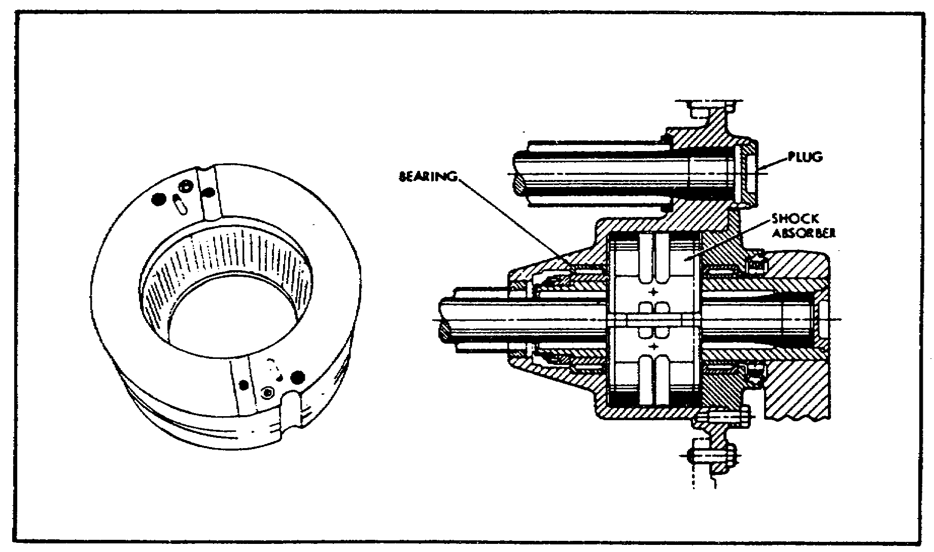
FIGURE 3. MODULAR ROTARY HYDRAULIC
SHOCK ABSORBER.

Engine oil is used to achieve damping, as well as to lubricate the bearings of the upper roadarm spindle assembly at the shock absorber stations. When oil is poured into the fill port, located on the external face of the housing, it automatically floods the spindle bearings, fills the shock, and finally fills the reservoir; each of the six shock absorber stations uses approximately three quarts of oil, of which 1.5 quarts are located in the reservoir. The design is such that overfill is impossible because the fill port establishes the maximum fill level. Monitoring of the oil level is through an external sight gage.

c. Support Rollers. Two support rollers per vehicle side are used to support and guide the upper track segment. Each support roller consists of a 11 inch diameter single steel wheel, integral with the wheel hub. The support roller housings are welded to the hull. The support roller assembly is shown in figure 4 on the following page. The rollers are grease-lubricated, and are sealed with lip-type seals.

6
PRIN. & T/S OF SUSPEN. SYS M1 - OD0479 - LESSON 1/TASK 1

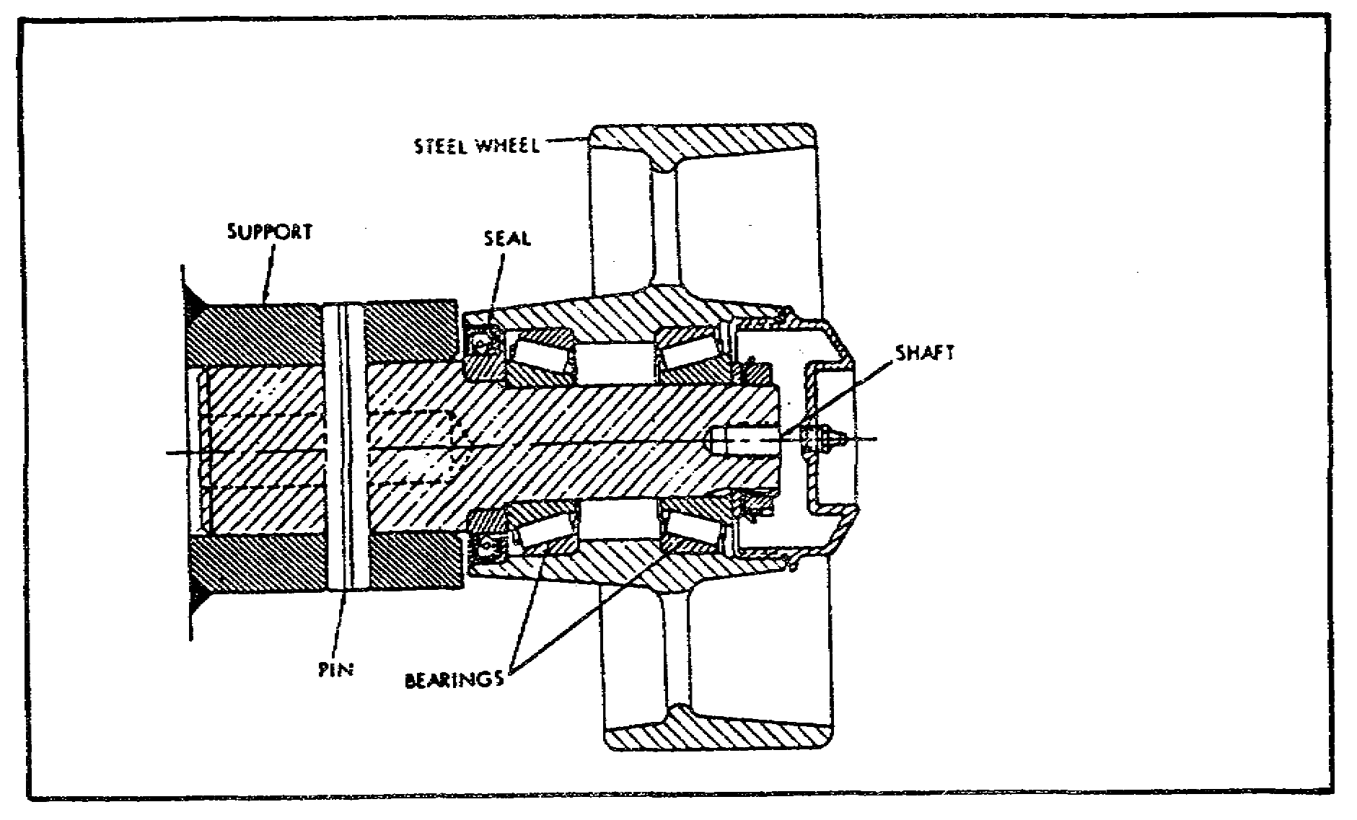
FIGURE 4. SINGLE WHEEL SUPPORT ROLLER.

d. Roadarm Assembly. The suspension system includes 14 roadarm assemblies (seven roadwheel stations on each side of the vehicle) with a built-in roadwheel camber. All roadarm assemblies contain two needle-type bearings. The housings at stations 1, 2, and 7 contain provisions for retention of the shock absorbers and have an integral reservoir for retaining the oil and supplying the oil to the shock absorbers.

All housings are interchangeable from right to left. The outboard seals at all roadarm upper spindle positions are a metal face-type which provide positive sealing and prevent outside contamination from entering the bearings. At the inboard upper spindle positions, face-type seals are also used at stations 1, 2, and 7, to seal the shock absorber oil. The inboard seals are grease lubricated, and are elastomeric lip seals. None of the inboard seals are exposed to dirt. The roadarm lower spindles, which mount the roadwheel hub assemblies. (figure 5 on the following page), contain two tapered roller bearings and face-type seals, and are lubricated with oil. The roadwheel hub assembly, which is used to mount the roadwheel idler wheels at each station, includes the hub, seals, bearing adjustment components, screws, and the inboard and outboard bearings.

7
PRIN. & T/S OF SUSPEN. SYS M1 - OD0479 - LESSON 1/TASK 1

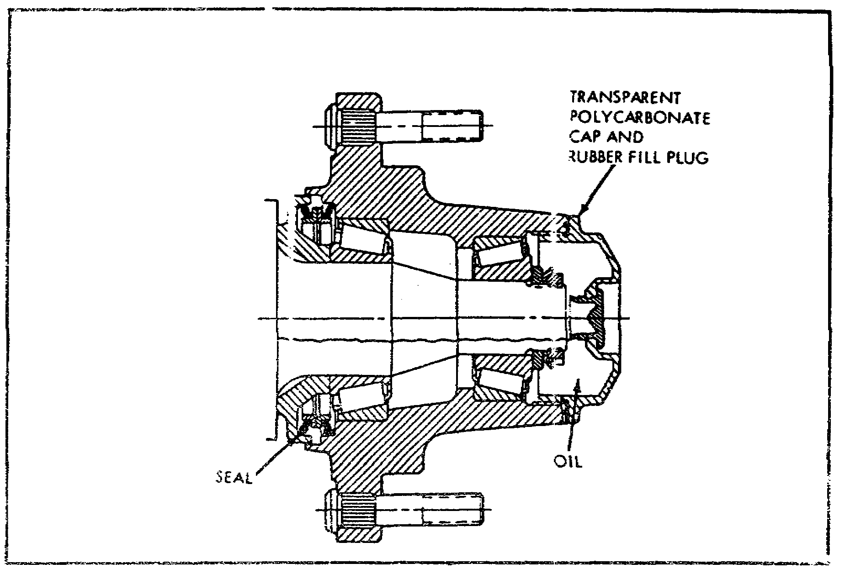
FIGURE 5. ROADWHEEL HUB ASSEMBLY.

e. Roadwheel Assembly. Thirty-two roadwheels are required per tank, 14 stations providing the ground support and two used as compensating idlers. The roadwheels (figure 6) are constructed of forged aluminum for minimum weight, and contain integral bonded rubber tires.

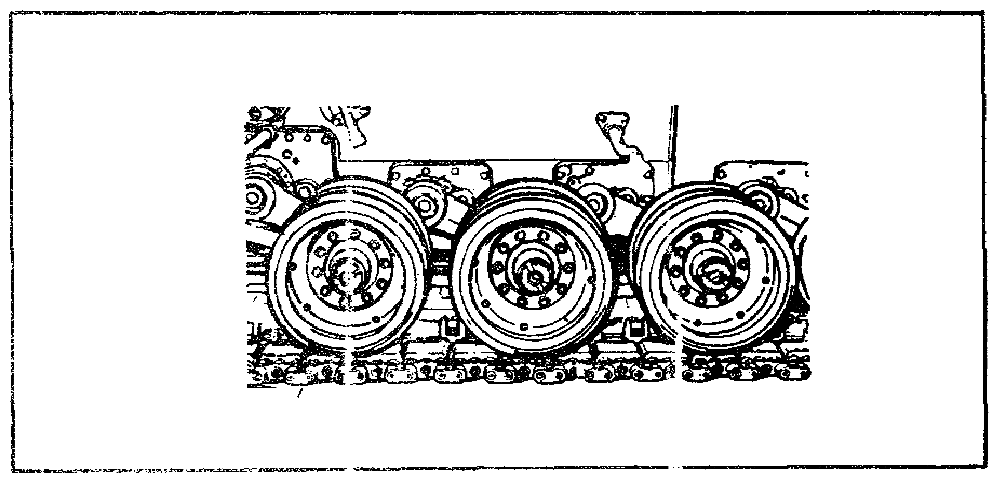
FIGURE 6. ROADWHEELS.

8
PRIN. & T/S OF SUSPEN. SYS M1 - OD0479 - LESSON 1/TASK 1

Steel wear plates with pressed-in studs are attached to the roadwheels with washers and self-locking nuts. These wear plates provide the wear surface for contact with the track center guides.

f. Compensating Idlers and Track Adjusting Link. The compensating idlers consist of 25 inch diameter dual wheels, interchangeable with and identical to the roadwheels and attached to pivotally mounted idler arms. Track compensation, under dynamic vehicle conditions, is achieved by interconnection of the idler arms and the number one roadarms through the track tension adjusting link.

Figure 7 illustrates the interconnection of the idler arm and number one roadarm with the track adjusting link. A standard grease gun, part of the vehicle on-equipment-materiel (OEM), is used to accomplish this task. A pressure relief type valve is incorporated as part of the track adjusting link. This valve automatically opens when the proper pressure has been reached for correct track tension. The escaping grease will be plainly visible to indicate that proper tension has been achieved. After proper tension is achieved, the link is mechanically locked.

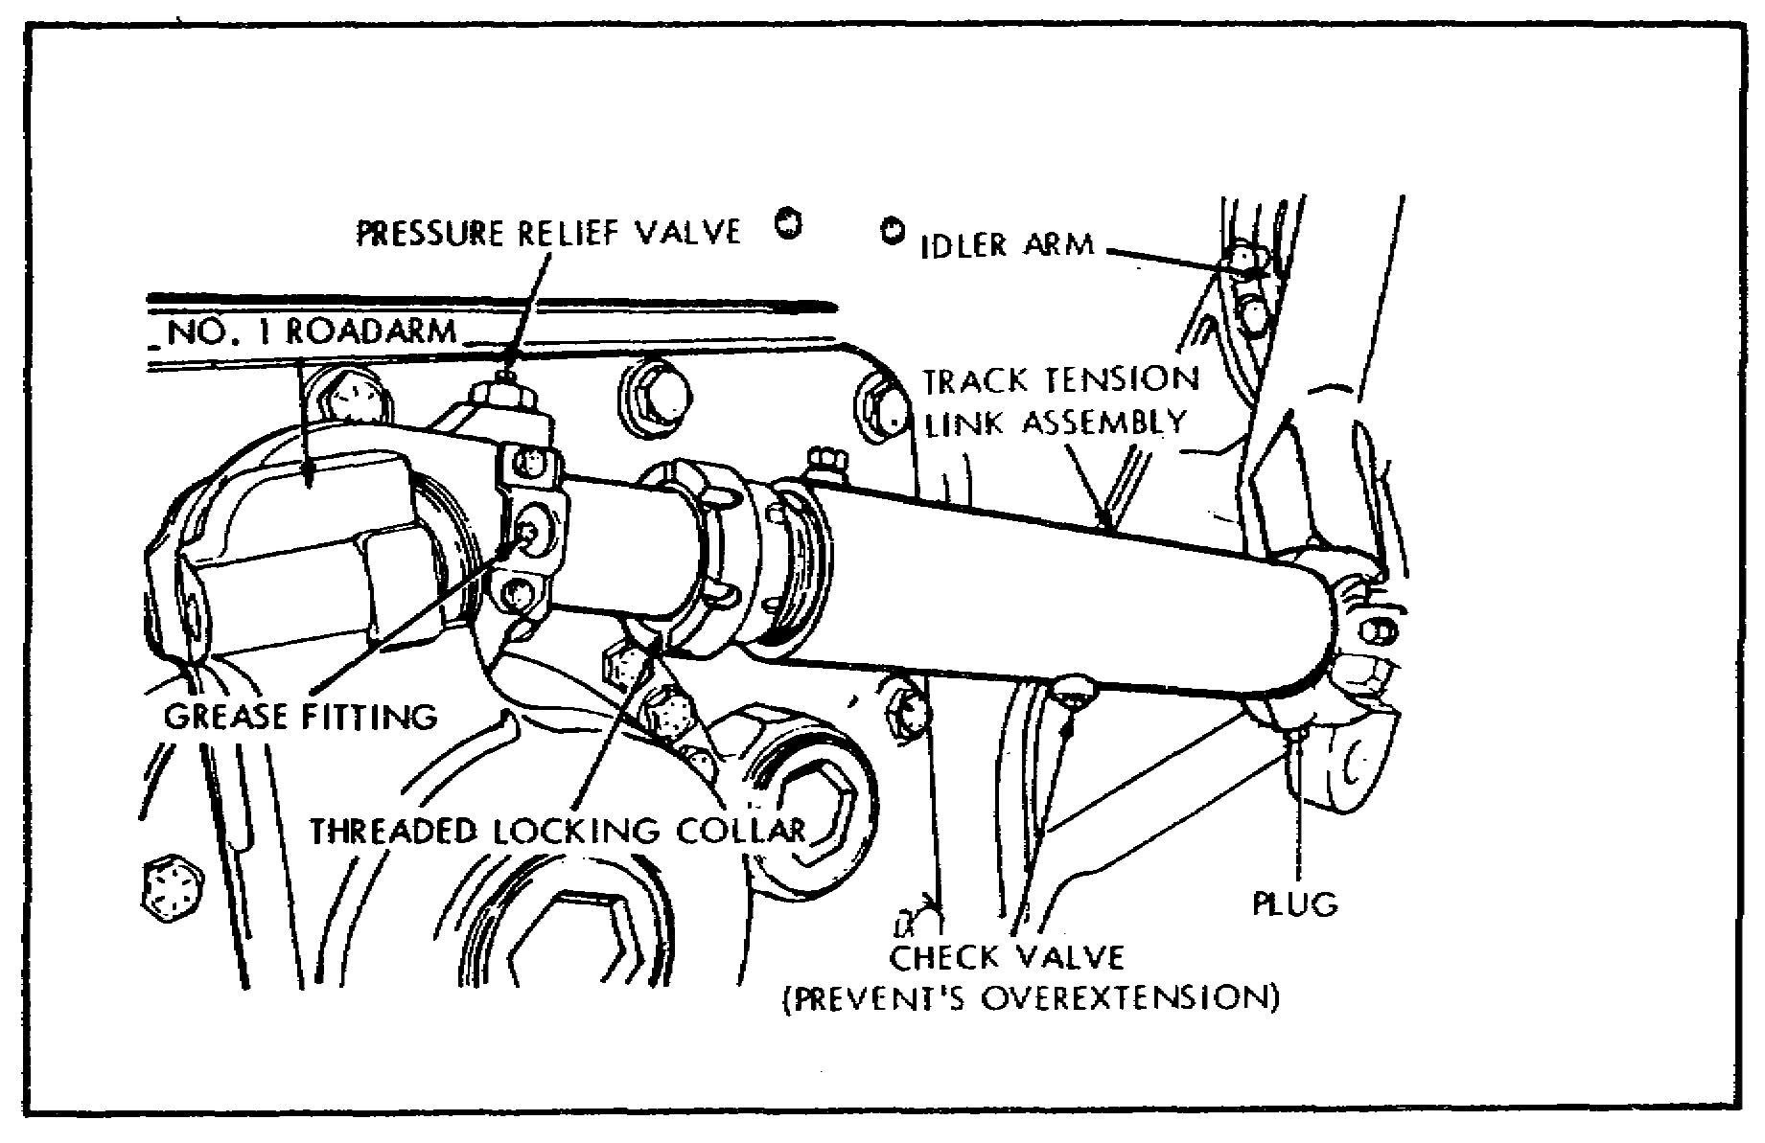
FIGURE 7. TRACK ADJUSTING LINK.

9
PRIN. & T/S OF SUSPEN. SYS M1 - OD0479 - LESSON 1/TASK 1

g. Hub and Sprocket Assembly. The hub and sprocket assembly (figure 8) consists of one steel hub and two sprockets. The hub contains large holes for dirt relief. The two steel sprockets are bolted to the hub to form the complete assembly.

Two features of the tank hub and sprocket designs are notable: the hub contains no guides for the track at the center, and the sprocket attaching bolt directions allow accessibility for maintenance.

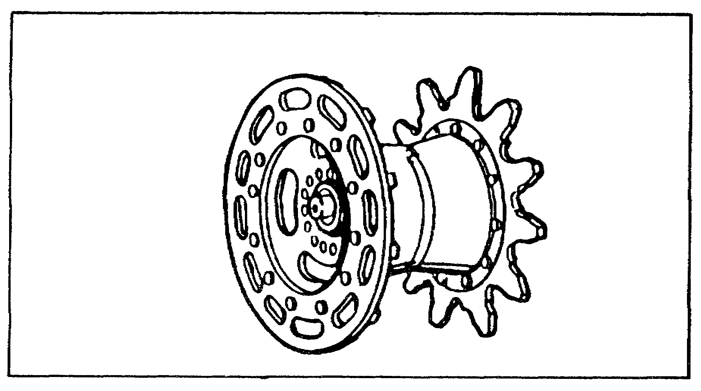
FIGURE 8. HUB AND SPROCKET ASSEMBLY.

Two hub and sprocket assemblies are required per tank and they interface with the final drive to transmit powerpack propulsion force to the tank tracks. In addition, the hub and sprocket assembly contains an outboard retaining ring to provide track guidance for severe terrain operating conditions. The retaining ring is secured to the hub and sprocket by 11 self-locking nuts, threaded to the sprocket with attaching bolts, on the outboard edge.

h. Track. The M1 track configuration, depicted in figure 9 on the following page, is an integral pad track with two rubber-bushed pins per shoe and integral rubber grousers. Each track is 25 inches wide, and each one contains 78 shoes, resulting in a weight of 8,930 pounds per tank. The track has demonstrated the potential of providing a 2000 mile average life under specified operating conditions, with no greater than a 10 percent shoe replacement.

10
PRIN. & T/S OF SUSPEN. SYS M1 - OD0479 - LESSON 1/TASK 1

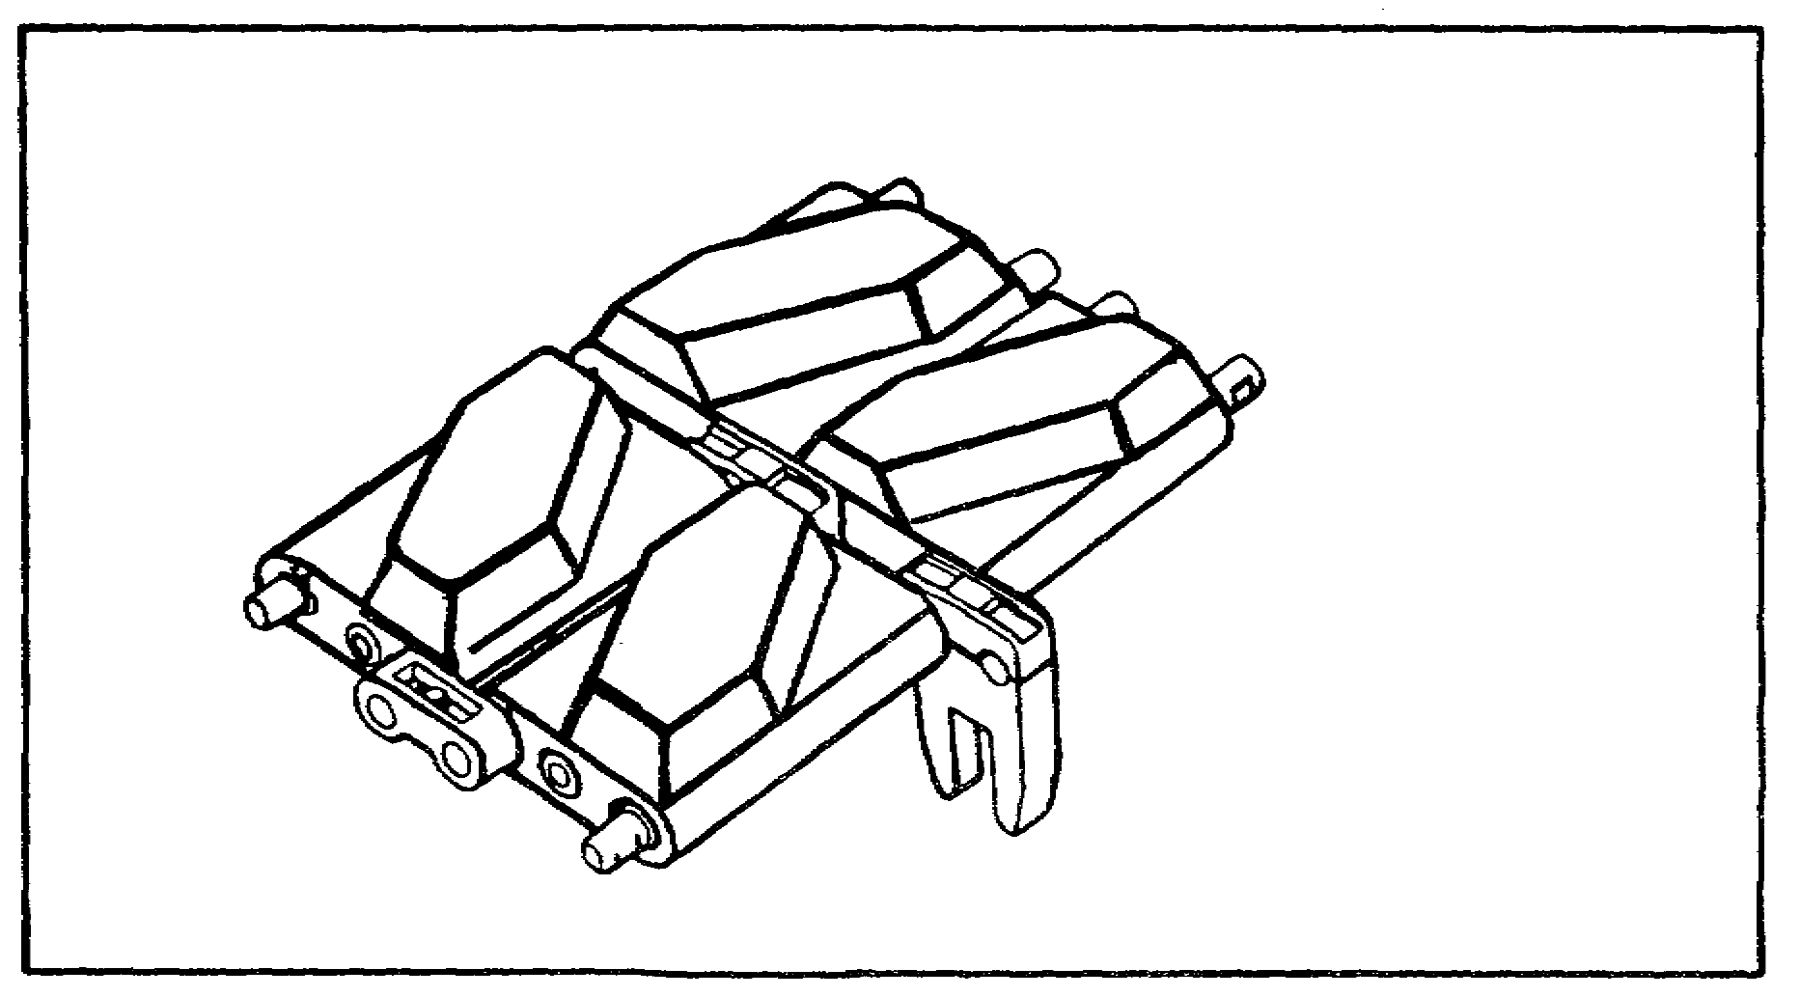
9. TRACK CONFIGURATION.

5. Short-Tracking

A significant suspension design provides the capability for operating the M1 tank in a shorttrack mode, in the event of damage being sustained from land mines. With damage to as many as three forward roadwheel stations, the M1 tank could continue to move by short-tracking.

a. Preparing the Tank for Short-Tracking. If the M1 tank (figure 10) has been damaged by mines, the following steps should be taken for accomplishing short-tracking operation:

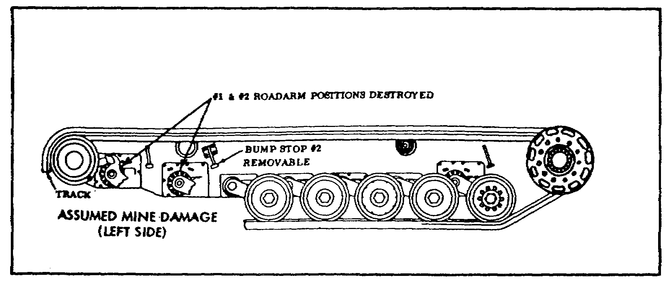
FIGURE 10. PREPARING VEHICLE FOR SHORT TRACKING.

11
PRIN. & T/S OF SUSPEN. SYS M1 - OD0479 - LESSON 1/TASK 1

o Remove first four skirt panels (not shown).

o Remove bump stop No. 2 by taking out four bolts.

o Remove damaged components (wheels, hubs, etc) from No. 1 arm.

o Remove number 1 torsion bar and move roadarm up against bump stop. Then re-install the torsion bar.

o Remove number 2 torsion bar and roadarm completely.

o Reverse No 3 roadarm.

- Remove torsion bar.

- Reverse roadarm (making it a leading arm) by backing the vehicle over a depression in the ground (either from a mine blast or dug by hand) as shown in figure 11.

- With the roadarm at 45 degrees, re-install the torsion bar.

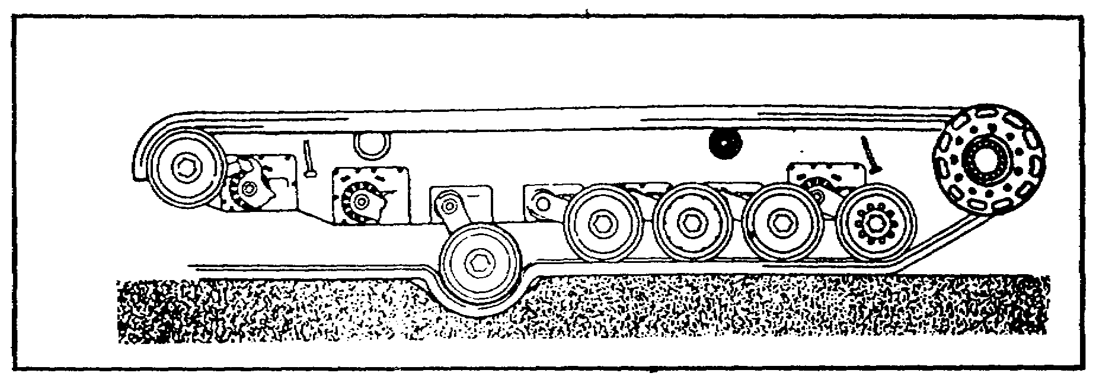
FIGURE 11. REVERSING NO. 3 ROADWHEEL.

NOTE

The track should be shortened to the length required to fit.

o With the No. 3 roadarm in the leading position, wrap the track around the roadwheel and No. 2 support roller, as shown in figure 12 on the following page.

12
PRIN. & T/S OF SUSPEN. SYS M1 - OD0479 - LESSON 1/TASK 1

o Using track jacks, connect the track together, by installing the center guides and end connectors.

o Short tracking is complete and the tank may be moved as required.

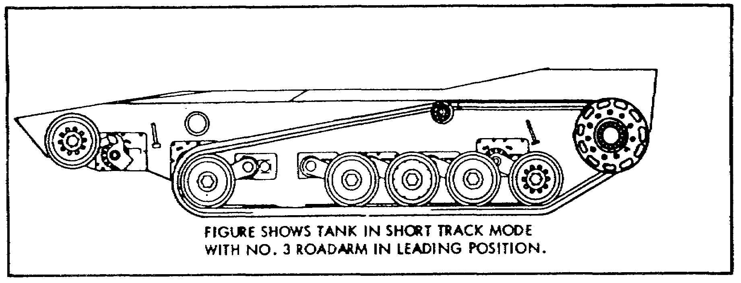
FIGURE 12. M1 TANK IN THE SHORT TRACK MODE.

6. Preventive Maintenance Checks and Services (PMCS)

The PMCS on the M1 tank is performed by the crew. However, when the vehicle is in the motor pool for unit level maintenance, the mechanic needs to know if the PMCS has been performed correctly. In some cases, the problem may be neglect of PMCS or the result of PMCS done incorrectly. This section of the text will discuss the PMCS on the suspension system of the M1 tank.

a. Adjusting L
ink Assembly. There are two track adjusting links on the M1 tank. They are located on the right and left side on the front of the vehicle, as shown in figure 13 on the following page.

To check the adjusting link (figure 13), the number one skirts have to be open. Refer to figure 14, on the following page, and perform the following steps:

o Look for loose or missing hardware and lube fitting (1).

o Check for loose or missing lock bolt (2).

o If grease comes out of the relief valve (3), check that locknut (4) is secure against the barrel (5).

13
PRIN. & T/S OF SUSPEN. SYS M1 - OD0479 - LESSON 1/TASK 1

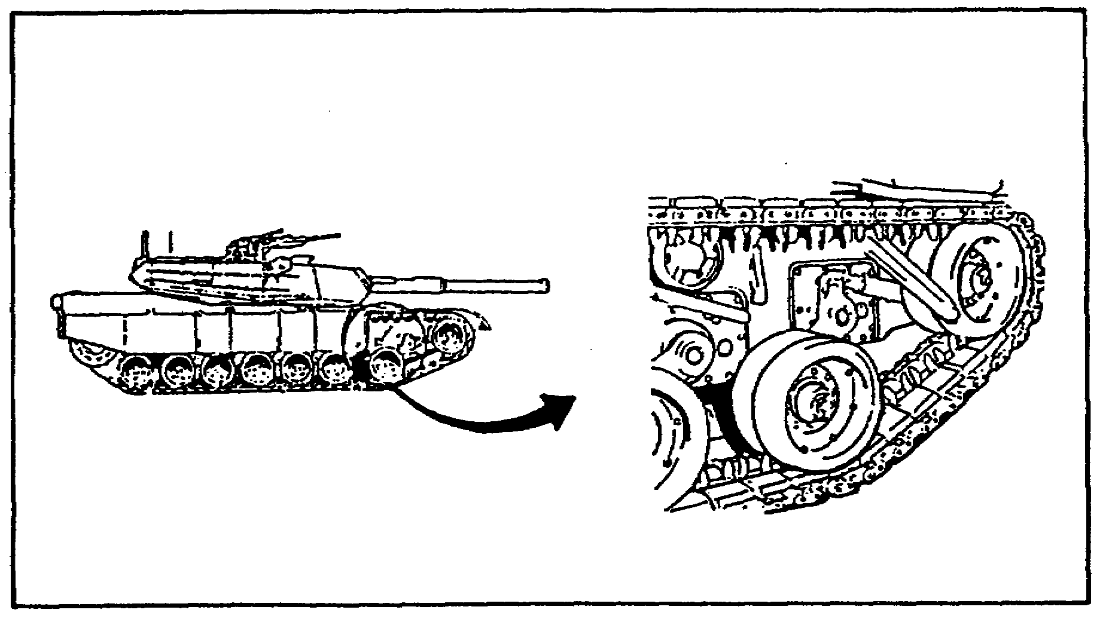
13. ADJUSTING LINK ASSEMBLY.

b. Track Tension. Refer to figure 14. Check the track tension by performing the following steps:

o Connect a grease gun and flexible adapter (6) to the fitting (1) and pump grease into the fitting (1) until the grease spurts out of the relief valve (3).

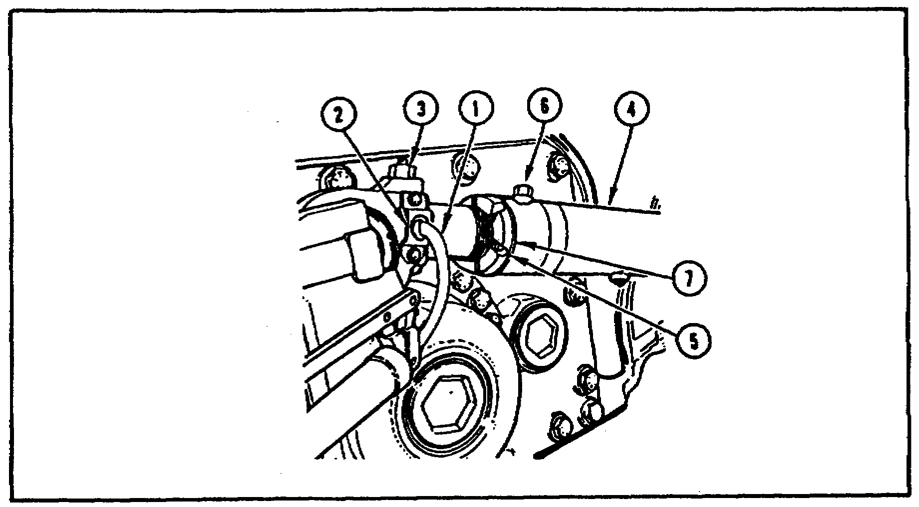
FIGURE 14. ADJUSTING LINK ASSEMBLY.

14
PRIN. & T/S OF SUSPEN. SYS M1 - OD0479 - LESSON 1/TASK 1

o If the adjusting link (7) moves no more than 1/8 inch from the locknut (4), the track tension is correct. If the adjusting link (7) moves more that 1/8 inch from the locknut (4), the mechanic should refer to TM 9-2350-255-10-3 to adjust the track.

c. Roadwheel and Compensating Idler Hubs and Arms. To check that roadwheel and compensating idler hubs and arms (figure 15) are serviceable, the mechanic should do the following:

o Look for oil leaks around the hubs (8) at the inner and outer roadwheels (9).

o After operation, touch-test the hubs (8) with the hand. Check for one hotter than the others.

WARNING
Hubs can be very hot. Use care when touch-testing the hubs

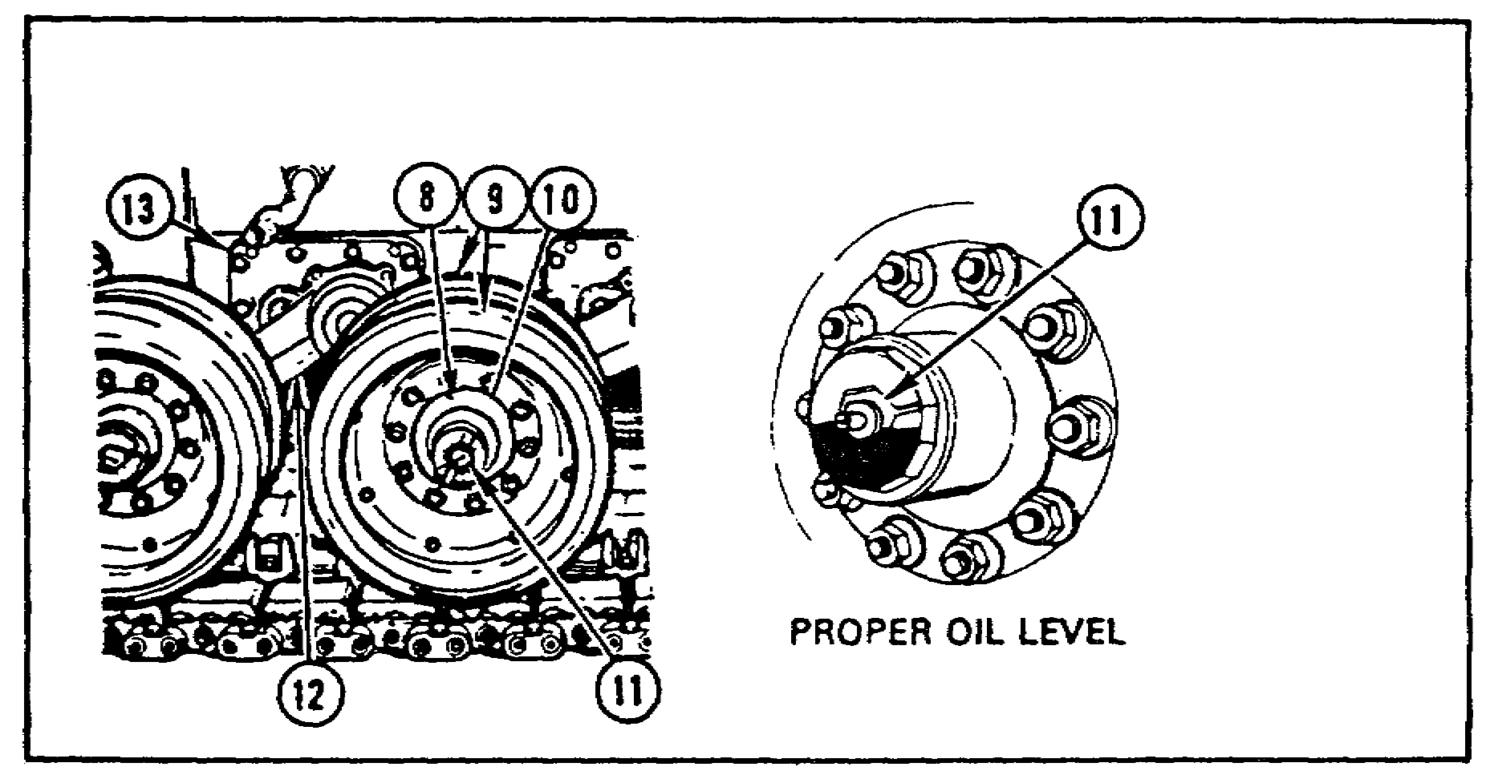
FIGURE 15. ROADWHEEL AND COMPENSATING
IDLER HUBS AND ARMS.

o Look at the hub caps (10), the oil level should be to the bottom of the hole for the filler plug (11). If the oil level is low, add oil in accordance with the proper lubrication order. If the oil has a milky color, it is contaminated and the vehicle should be turned in to support maintenance for repair.

15
PRIN. & T/S OF SUSPEN. SYS M1 - OD0479 - LESSON 1/TASK 1

o Check for missing plugs (11).

o Check the upper end of the arms (12) for leaks at the housings (13).

o Check the arms (12) for bends or deep gouges.

d. Roadwheels and Compensating Idler Wheels. To check the roadwheels and compensating idler wheels (figure 16), the mechanic should do the following:

o Check all roadwheels and compensating idler wheels for bent, broken or missing wheels (9).

o Make sure that the wearplates are not cracked, gouged or missing.

o Ensure that not more than 50 percent of the rubber on the roadwheels and compensating idler wheels is chunked or separated.

o Check that all mounting nuts and bolts (15) are secure.

o If the wearplates are loose or missing, check for bent or broken centerguides (16).
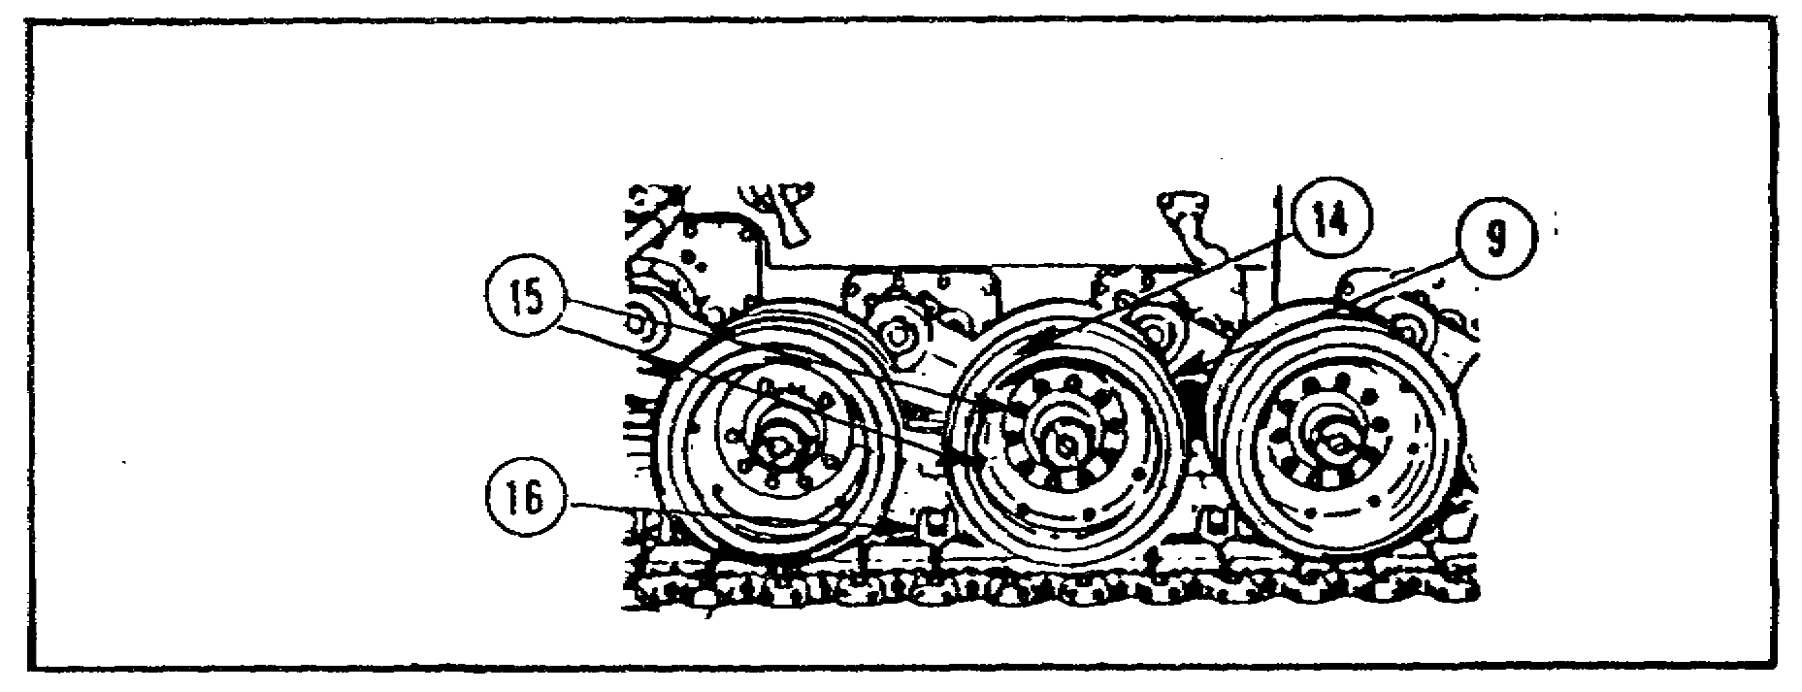
FIGURE 16. ROADWHEELS AND COMPENSATING
IDLER WHEELS.

e. Shock Absorber. To check the shock absorbers (figure 17 on the following page) for serviceability do the following:

o Check the shock absorber sight gages (17) for the proper oil level. The indicator ball (18) should be between the middle and top of sight gage (17).

16
PRIN. & T/S OF SUSPEN. SYS M1 - OD0479 - LESSON 1/TASK 1

o If the oil level is low, check for leaks before adding oil.

o Touch-test the shock absorber housing (19) with the back of the hand. If the housing is colder than other shock absorber housings, the shock absorber in the cold housing may be broken.

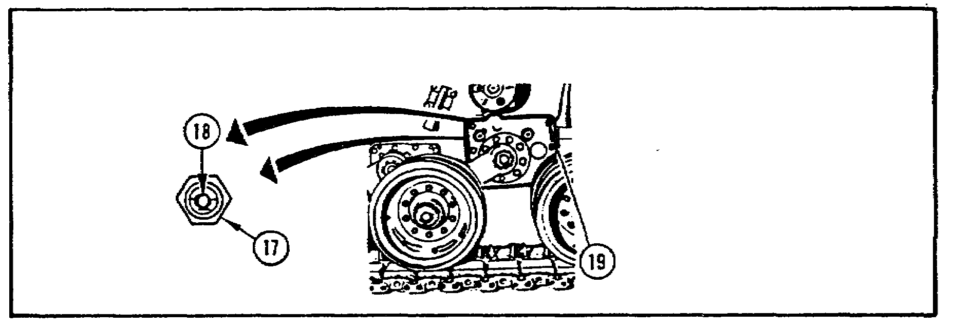
FIGURE 17. SHOCK ABSORBER.

f. Torsion Bars. To check the torsion bars (figure 18), the mechanic should do the following:

o At roadwheel arm positions 2 through 6, a crowbar should be used to test the torsion bars. This is done by prying up on the roadwheels (20) with the crowbar. If the roadwheel cannot be lifted, the torsion bar is good.

o At roadwheel arms 1 and 7 (21), look for a tilt of the tank (22) or lifting of the roadwheel (21) and the track (23) off the ground, to indicate a broken torsion bar.

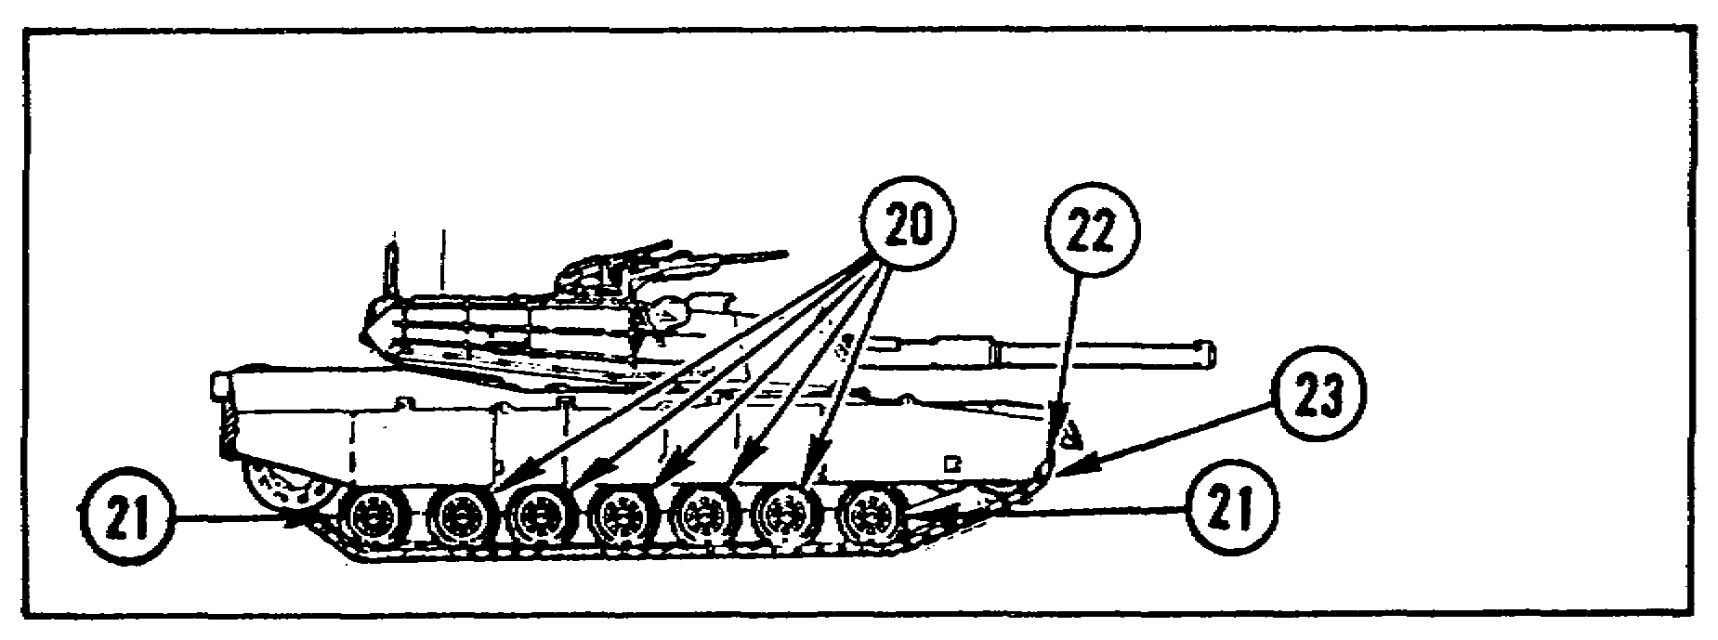
FIGURE 18. CHECKING THE TORSION BARS.

17
PRIN. & T/S OF SUSPEN. SYS M1 - OD0479 - LESSON 1/TASK 1

g. Support Roller Assembly. To check the support rollers (figure 19), the following should be done:

o Open number two and number six skirts.

o Look for grease leakage and missing or damaged lubrication fittings (35).

o Check the wheel (36) for cracks or unusual wear.

o Check the spindle support (37) for missing or loose retaining pin (38).

o Check the support roller hub cap (39) for cracks, damage, grease leakage, or loose fit.

o Touch-test the hub (34) ensure it is not hot.
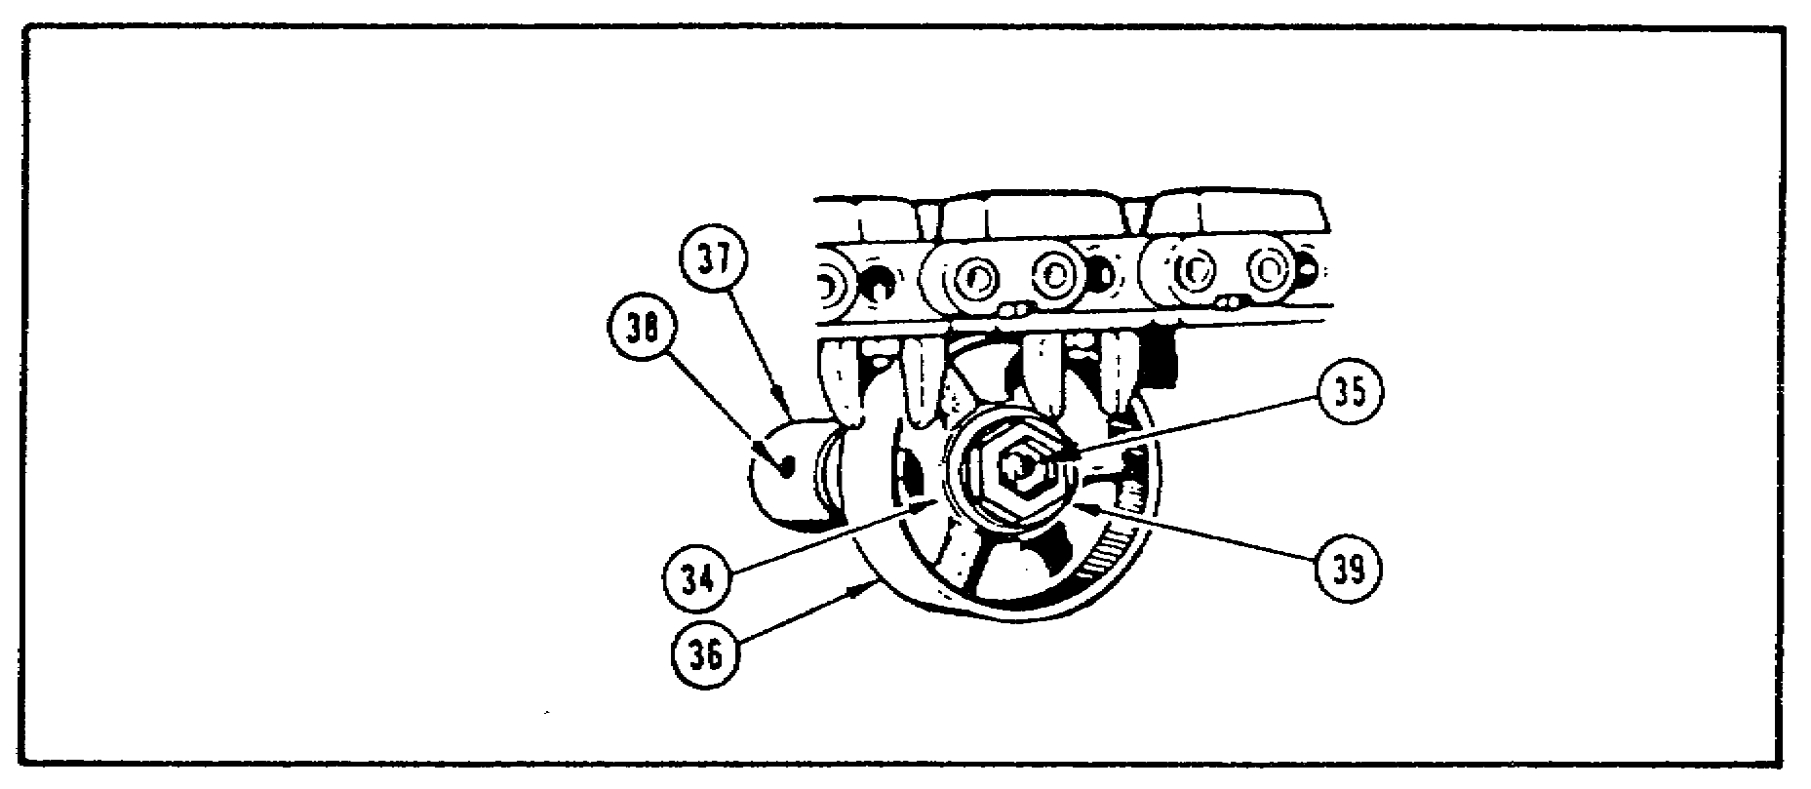
FIGURE 19. SUPPORT ROLLER ASSEMBLY.

h. Hub and Sprocket Assembly. To check the hub and sprocket assembly (figure 20 on the following page), the mechanic should do the following:

o Check the inner and outer sprocket (40) for cracks and worn or gouged teeth.

o Check the sprocket wear mark (41). If the teeth are worn at any point to the back edge of the wear mark (41.1), the mechanic should troubleshoot the track according to the appropriate technical manual.

o Check for missing or loose bolts.

18
PRIN. & T/S OF SUSPEN. SYS M1 - OD0479 - LESSON 1/TASK 1

o Check the hub (42) for cracks, sharp edged gouges, and loose or missing mounting bolts.

o Check the track retainer (43) for bends, cracks and missing bolts.

o Check the final drive cover (43.1) for loose or missing bolts.

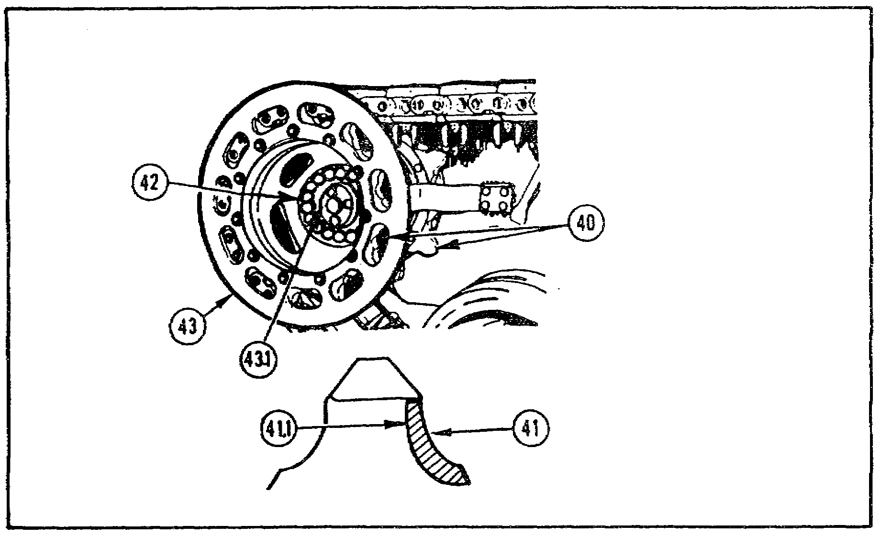
FIGURE 20. HUB AND SPROCKET ASSEMBLY.

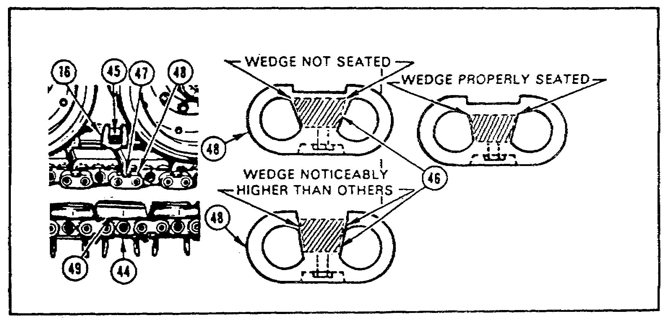
FIGURE 21. TRACK ASSEMBLY.

19
PRIN. & T/S OF SUSPEN. SYS M1 - OD0479 - LESSON 1/TASK 1

i. Track Assembly. To check the track assembly (figure 21 on the previous page), do the following:

o Open skirts as needed and check the shoe assemblies (44) for missing, bent or broken centerguides (16) and nuts (45).

o Look for missing, loose, or improperly seated wedges (46) or bolts (47) in the end connectors (48).

o Look for dead track shoes (49). A dead track shoe appears out of line with the other shoes.

7. Conclusion

By knowing the components and understanding the principles of operation, the mechanic is better able to troubleshoot, repair, and maintain the suspension system on the M1 tank.

The next lesson will cover the procedures for troubleshooting the suspension system.

20
PRIN. & T/S OF SUSPEN. SYS M1 - OD0479 - LESSON 1/PE 1

PRACTICAL EXERCISE 1

1. Instructions

Read the scenario and respond to the requirements that follow the scenario.

2. Scenario

Your first sergeant informs you that you are to report to the battalion commander at 0900 hours today. At 0900 you report to Colonel Harris as directed, and he tells you to have a seat. He informs you that one of his other companies in the battalion is experiencing a big problem keeping the M1 tanks operational, and that he wants you take over as the motor sergeant.

The first thing you do when you get to the motor pool is look over the deadline report; you see that three tanks have been non-operational for two weeks with problems in the suspension system.

It is apparent that the personnel in the motor pool are not knowledgeable on the suspension system, so you call all them together and inform them that you will give a class on the M1 tank suspension system tomorrow at 0800 hours.

After writing your lesson plan, you prepare a list of questions to test the personnel on the material that you will cover in the class.

Requirement

Prepare an answer sheet for the questions that follow.

a. The track on the M1 tank is supported and alined between the drive sprocket and compensating idler by what?

b. What type of suspension system does the M1 tank have?

c. How is the oil level checked in the shock absorber on the M1 tank?

d. What is the purpose of the steel wear plates on the roadwheels?

21
PRIN. & T/S OF SUSPEN. SYS M1 - OD0479 - LESSON 1/ PE 1

e. When checking the track tension on the M1 tank, how can the mechanic tell if the tension is correct?

f. If a roadwheel on the M1 tank can be lifted with a crowbar, what does this indicate?

g. How can the mechanic recognize a dead track shoe on the M1 tank track?

h. When reversing the No 3 roadarm on the M1 tank, for short tracking, at what angle should it be?

i. How are the support roller housings attached to the hull?

j. What are the three general functions of the suspension system on the M1 tank?

22
PRIN. & T/S OF SUSPEN. SYS M1 - OD0479 - LESSON 1/ PE 1

LESSON 1. PRACTICAL EXERCISE - ANSWERS

Requirement

a. Track support rollers.

b. Hydromechanical.

c. Through an external sight gage.

d. To keep the track center guides from wearing out the aluminum roadwheels.

e. When grease is pumped in the adjusting link, the link should not move more than 1/8 inch from the locknut.

f. That the torsion bar is broken.

g. The dead shoe appears out of line with the other shoes.

h. 45 degrees.

i. They are welded.

j. (1) Lay a roadbed and move the tank in the process, (2) support the weight and absorb shock loads and (3) provide a smooth ride.

23
PRIN. & T/S OF SUSPEN. SYS M1 - OD0479 - LESSON 2/TASK 1

LESSON 2

PROCEDURES FOR TROUBLESHOOTING THE
SUSPENSION SYSTEM ON THE M1 TANK

TASK 1. Describe the procedures for
troubleshooting the suspension system.

CONDITIONS

Within a self-study environment aid given the subcourse text, without assistance.

STANDARDS

Within 2 hours

REFERENCES

No supplementary references are needed for this task.

1. Introduction

When any equipment malfunctions, it is not always obvious what is causing the problem. A description as general as "vehicle rides rough" does not point directly to the specific malfunctioning component, so that the problem can be fixed. Knowing how to isolate the faulty component is an essential part of materiel maintenance. This process of systematic isolation of defective components by analyzing trouble symptoms and testing for defective components, so that corrective action can be taken, is known as troubleshooting. Troubleshooting, in the general sense, is a logical thought process. When applied methodically, this thought process leads to the identification of defective parts, so that the malfunctioning equipment can be repaired or replaced.

This task deals with the troubleshooting approach and describes the procedures for troubleshooting the suspension system on the M1 tank.

24
PRIN. & T/S OF SUSPEN. SYS M1 - OD0479 - LESSON 2/TASK 1

2. Troubleshooting

Troubleshooting is a step-by-step process of finding the cause of problems with the vehicle, in this case, the M1 tank. This section will explain the overall approach used for troubleshooting.

a. Troubleshooting Index. The troubleshooting index is the master reference table used for locating troubleshooting information for a particular functional group. This index will be found in the troubleshooting manual for the equipment. Before doing any troubleshooting, the applicable technical manuals must be used.

The index lists each group or system and provides a reference, by figure number, to the troubleshooting information for that system.

b. Test Equipment Procedures Index. The test equipment procedures index (Table 3 on the following page) lists the test
equipment and special tools used for troubleshooting and provides a reference, by figure number, to the detailed instruction for their use.

25
PRIN. & T/S OF SUSPEN. SYS M1 - OD0479 - LESSON 2/TASK 1

TABLE 3. TEST EQUIPMENT PROCEDURES INDEX.
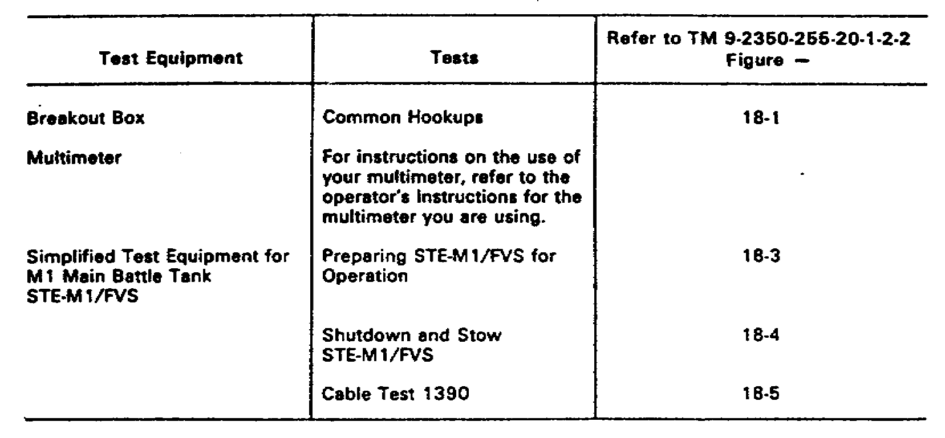
TABLE 4. TROUBLESHOOTING ROADMAPS.
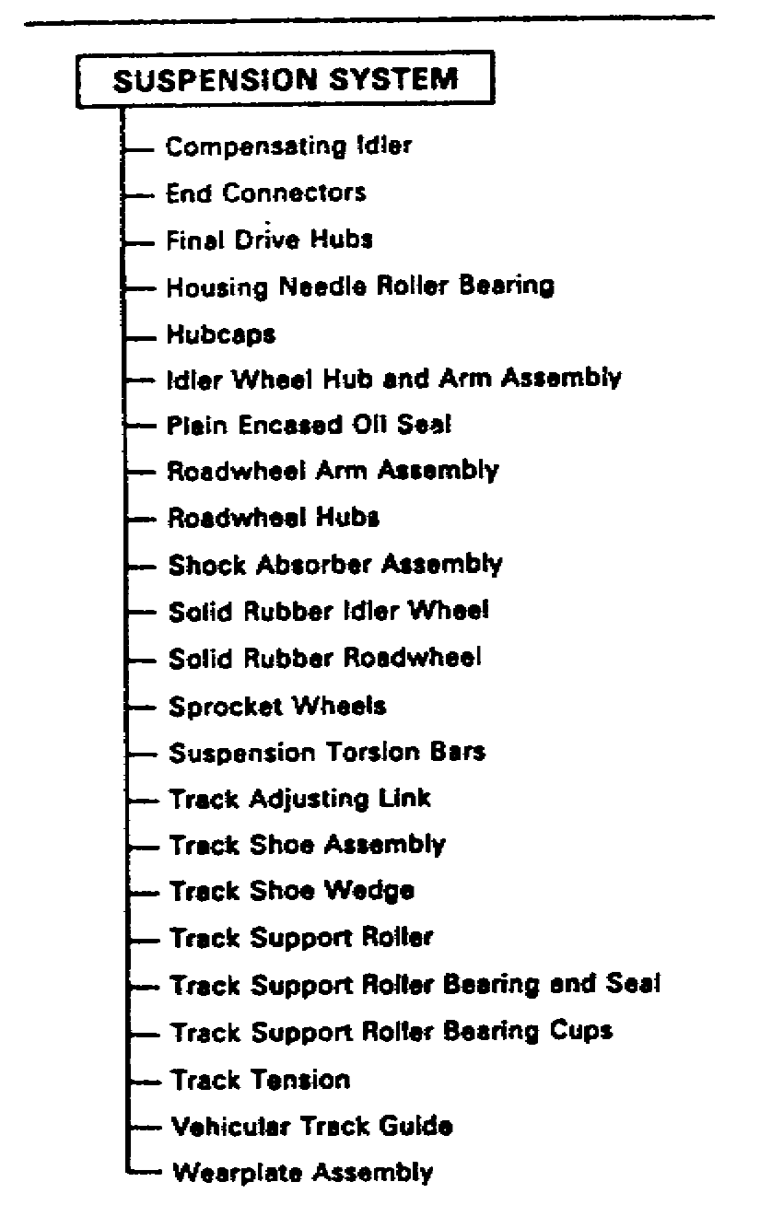
26
PRIN. & T/S OF SUSPEN. SYS M1 - OD0479 - LESSON 2/TASK 1

c. Troubleshooting Roadmaps. Troubleshooting roadmaps (Table 4 on the previous page) are provided for each functional system. They give the mechanic an overall view of the assemblies or piece parts included in each system.

d. Fault Symptom Indexes. Separate fault symptom index tables (Table 5) are provided for each functional group or system. Each table lists the fault symptoms for the system or subsystem, and refers to the TM and paragraph where the troubleshooting procedures for that system can be found. The symptom that the mechanic has may not be exactly as described in the indexes. The mechanic should find the symptom that most closely resembles the symptom that he has, and the referenced troubleshooting procedure. The indexes also contain a Resources Required column that lists the number of personnel required to carry out each troubleshooting procedure.

TABLE 5. FAULT SYMPTOM INDEX.
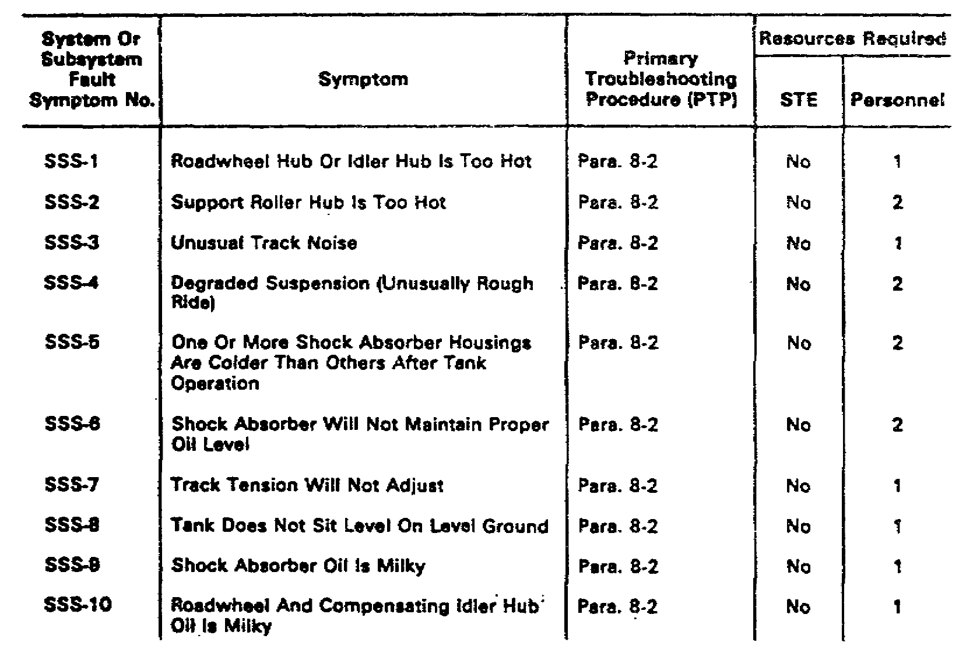
e. Troubleshooting Procedure. The troubleshooting procedures are in the form of fault isolation flowcharts (figure 22 on the following page). Each flowchart begins with a fault symptom

27
PRIN. & T/S OF SUSPEN. SYS M1 - OD0479 - LESSON 2/TASK 1

that can be seen, felt or heard during operation of the tank, without using test equipment. Step-by-step instructions for finding and correcting the fault are given for each symptom. When needed, illustrations are included for the symptom, showing locations of all test points and how each troubleshooting step should be done. If the tank still has problems after a troubleshooting procedure has been performed, the tank may have had more than one fault. Check the fault symptom index for another troubleshooting procedure and continue troubleshooting.

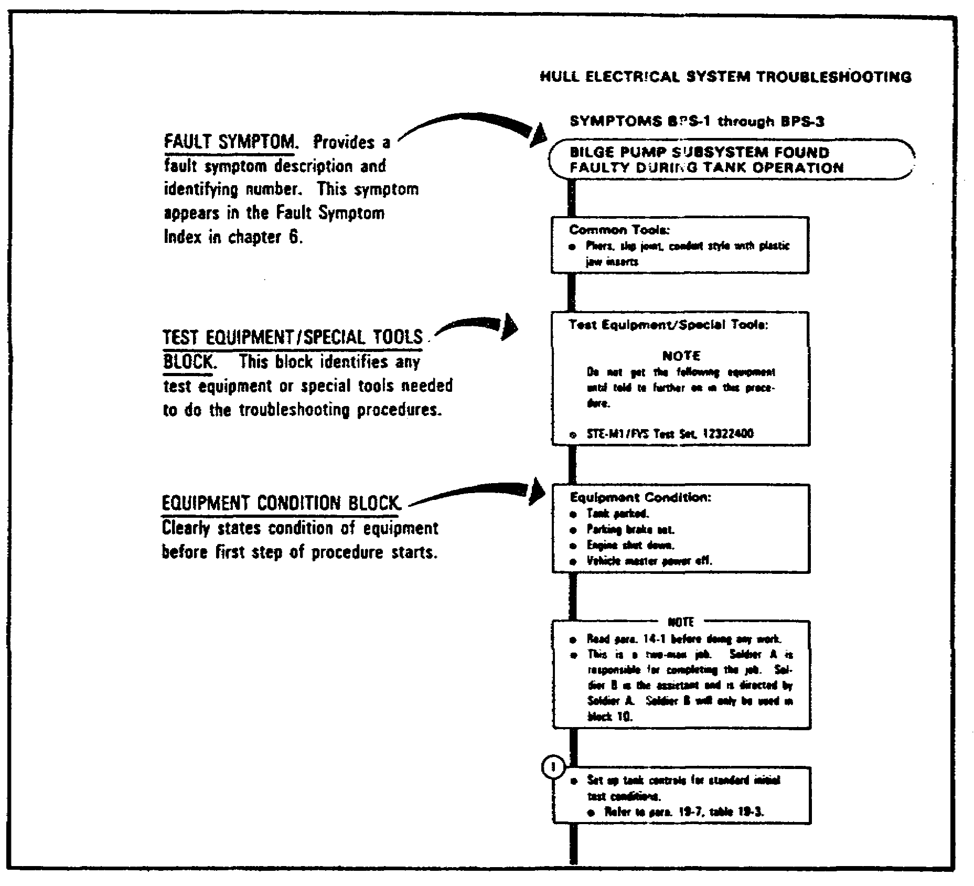
FIGURE 22. FAULT ISOLATION FLOWCHART.

f. Alternate Troubleshooting Procedures (ATP). Alternate troubleshooting procedures are also included in the manual.

28
PRIN. & T/S OF SUSPEN. SYS M1 - OD0479 - LESSON 2/TASK 1

ATP's for unit level provide troubleshooting procedures to be used when automated test equipment (ATE) is not available.

3. Typical Troubleshooting Approach

This section will explain how to use the troubleshooting approach, using the tables and supporting data covered in the preceding subsection.

a. Troubleshooting Steps. The first step in an effective troubleshooting approach is to note the three key steps that make for good troubleshooting. These three steps are:

o Identify the symptom.

o Find the right troubleshooting procedure.

o Use the troubleshooting procedure to locate and isolate the fault.

(1) Identify the Symptom. To identify the symptom, the mechanic should look at the DA Form 2404 (figure 23 on the following page) that was filled out by the crew. If not enough information is given to identify the symptom, ask the crew questions and get as much information as possible about the symptom. The mechanic should also make sure that there was no crew error in following the operator's procedure. If necessary, the mechanic should operate the tank to help verify the symptom.

WARNING
Do not try to operate the tank if there is any chance the symptom may injure personnel or damage the tank. Example: "No steering control."

Before operating the tank, notify nearby personnel and make sure the surrounding area is clear, to prevent injury to personnel or damage to the equipment.

29
PRIN. & T/S OF SUSPEN. SYS M1 - OD0479 - LESSON 2/TASK 1

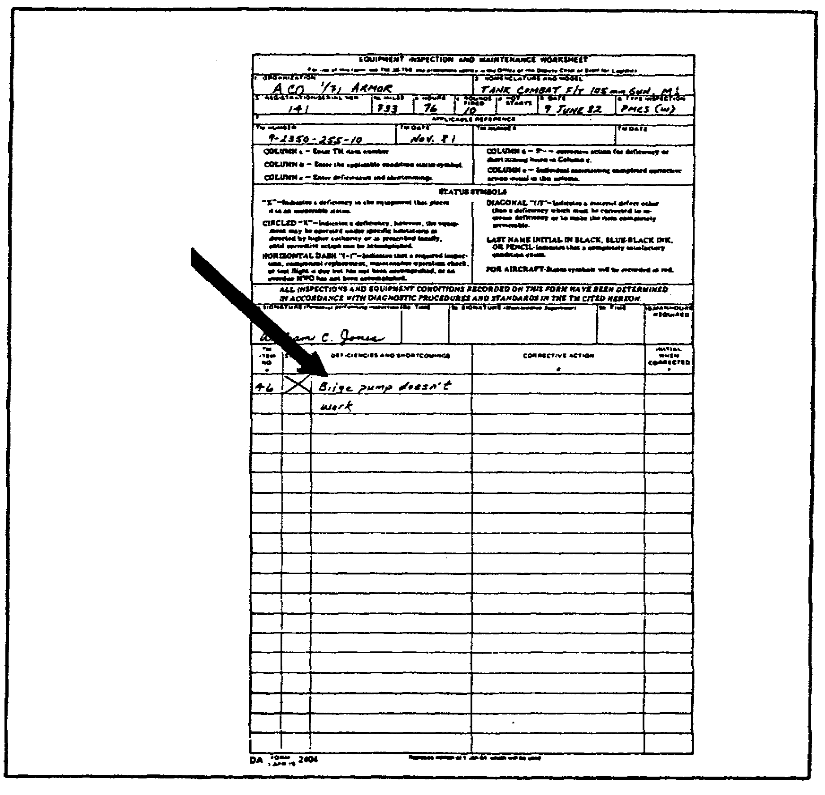
FIGURE 23. DA FORM 2404.

(2) Find the Right Troubleshooting Procedure. Once the symptom has been identified, the system or subsystem must then be identified. Frequently, the symptom itself suggests the suspect system. If the mechanic is unsure of the precise system or subsystem but has an idea of the faulty component, the troubleshooting roadmaps (figure 24 on the following page) in the troubleshooting manuals may be consulted. The roadmaps list the components which are replaced in the troubleshooting procedures; the components are listed by system or subsystem. The mechanic can find the suspect component, using a roadmap, and identify the system in which it is found.

30
PRIN. & T/S OF SUSPEN. SYS M1 - OD0479 - LESSON 2/TASK 1

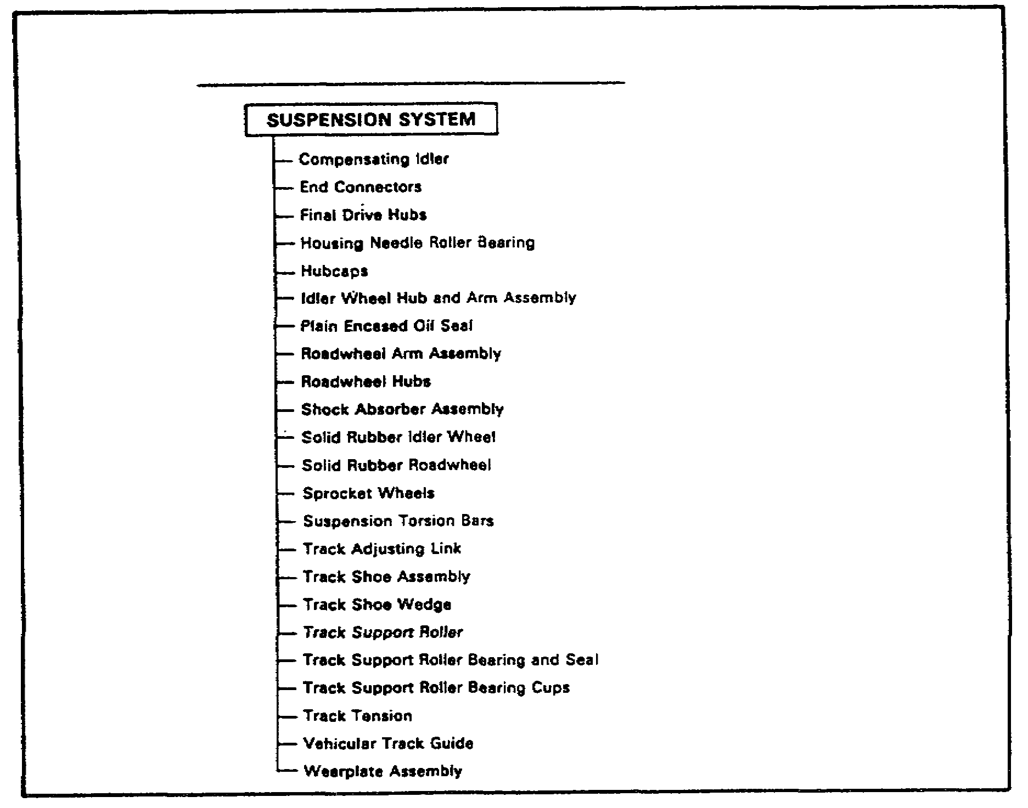
FIGURE 24. TROUBLESHOOTING ROADMAP.

(3) Use the Troubleshooting Procedure to Locate and Isolate the Fault. After identifying the problem system, the mechanic finds the Fault System Index table number and page number in the troubleshooting manual. After going to the correct Fault Symptom Index, the mechanic finds the fault symptom described by the tank crew, or observed by his own investigation. The Fault Symptom Index (figure 25 on the following page) directs the mechanic to the primary troubleshooting procedure (PTP) for symptom he is observing.

The columns beside the PTP state the resources required. They indicate whether the STE-M1/FVS test set is used in the PTP, and how many personnel are required to perform the PTP. The mechanic then proceeds to the specified troubleshooting technical manual (TM) to find the specified PTP. The TM gives the mechanic the fault symptom number, the figure number for the PTP, and a test number to be used with the STE-M1/FVS (commonly referred to as STE) when the STE is used as part of the PTP.

31
PRIN. & T/S OF SUSPEN. SYS M1 - OD0479 - LESSON 2/TASK 1

The TM also identifies alternate troubleshooting procedures (ATP) to be used for the symptom: these are not used unless there is no STE PTP, or the PTP steps specify that ATPs are to be used.

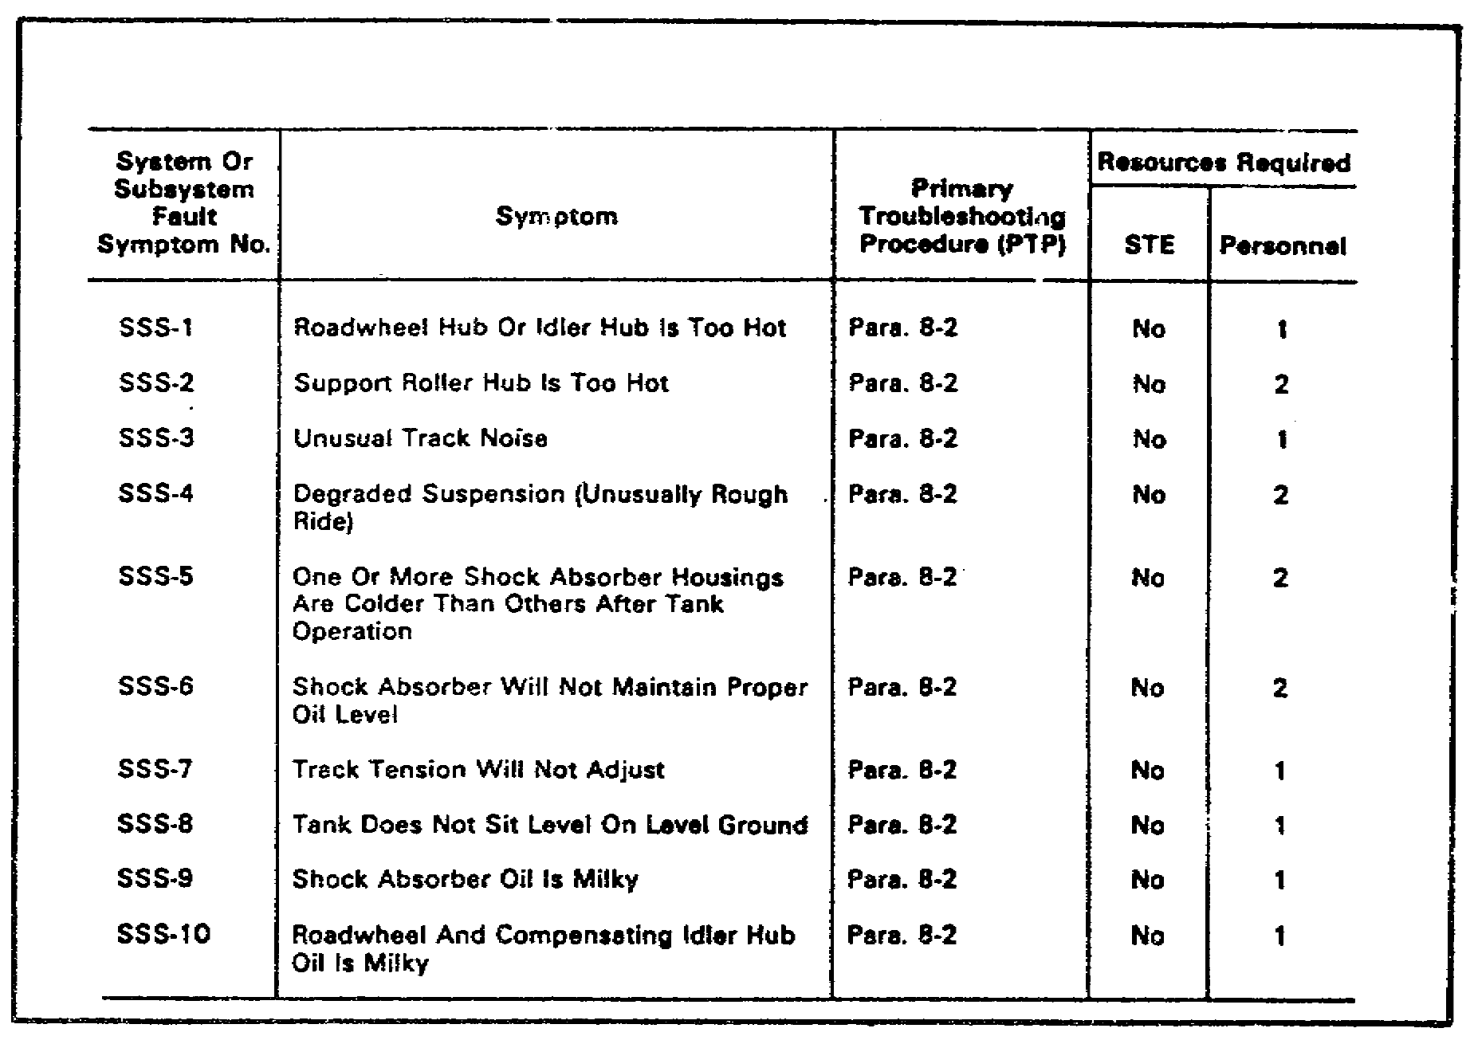
FIGURE 25. FAULT SYMPTOM INDEX.

The PTPs are organized as flow charts. A typical PTP flow chart is shown in figure 26 on the following pages.

The flow chart gives the mechanic the troubleshooting steps which must be followed to isolate a malfunctioning component. These steps may often take the mechanic in a variety of different directions, depending upon the given symptom and the response the mechanic gets to certain troubleshooting steps. This is called branching. It is not unusual for a troubleshooting task to branch. When a mechanic is faced with two possible directions, the PTP or the ATP will give the mechanic a question which requires a yes or no answer. Whichever response the mechanic receives from the previous steps of the troubleshooting task, that direction is followed, as directed by the PTP or ATP.

32
PRIN. & T/S OF SUSPEN. SYS M1 - OD0479 - LESSON 2/TASK 1

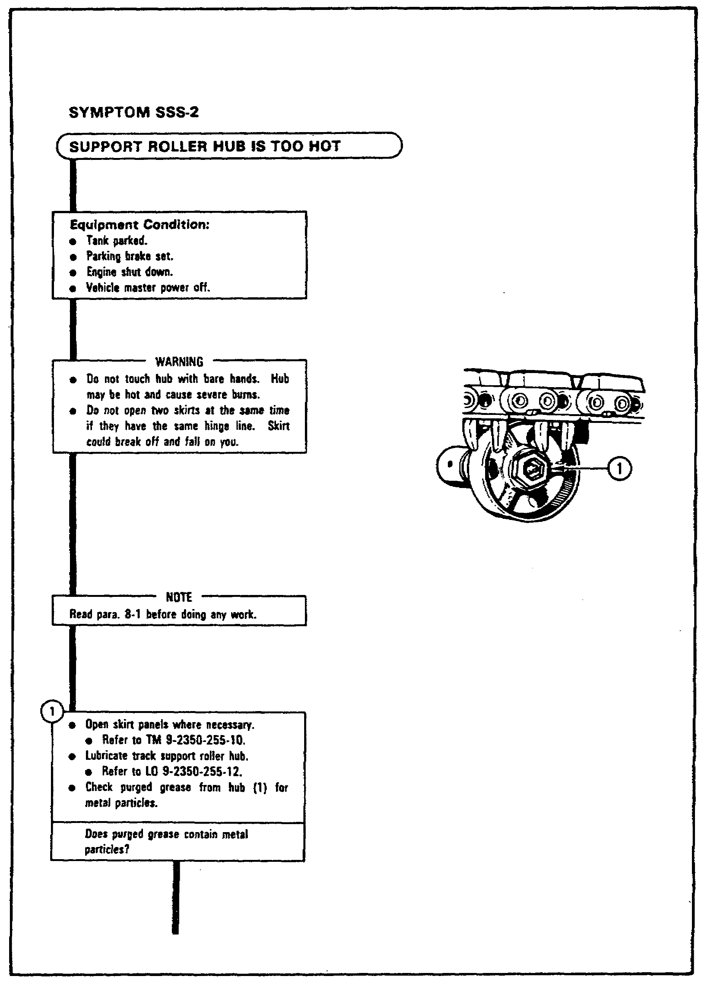
FIGURE 26. TYPICAL PTP FLOW CHART.

33
PRIN. & T/S OF SUSPEN. SYS M1 - OD0479 - LESSON 2/TASK 1

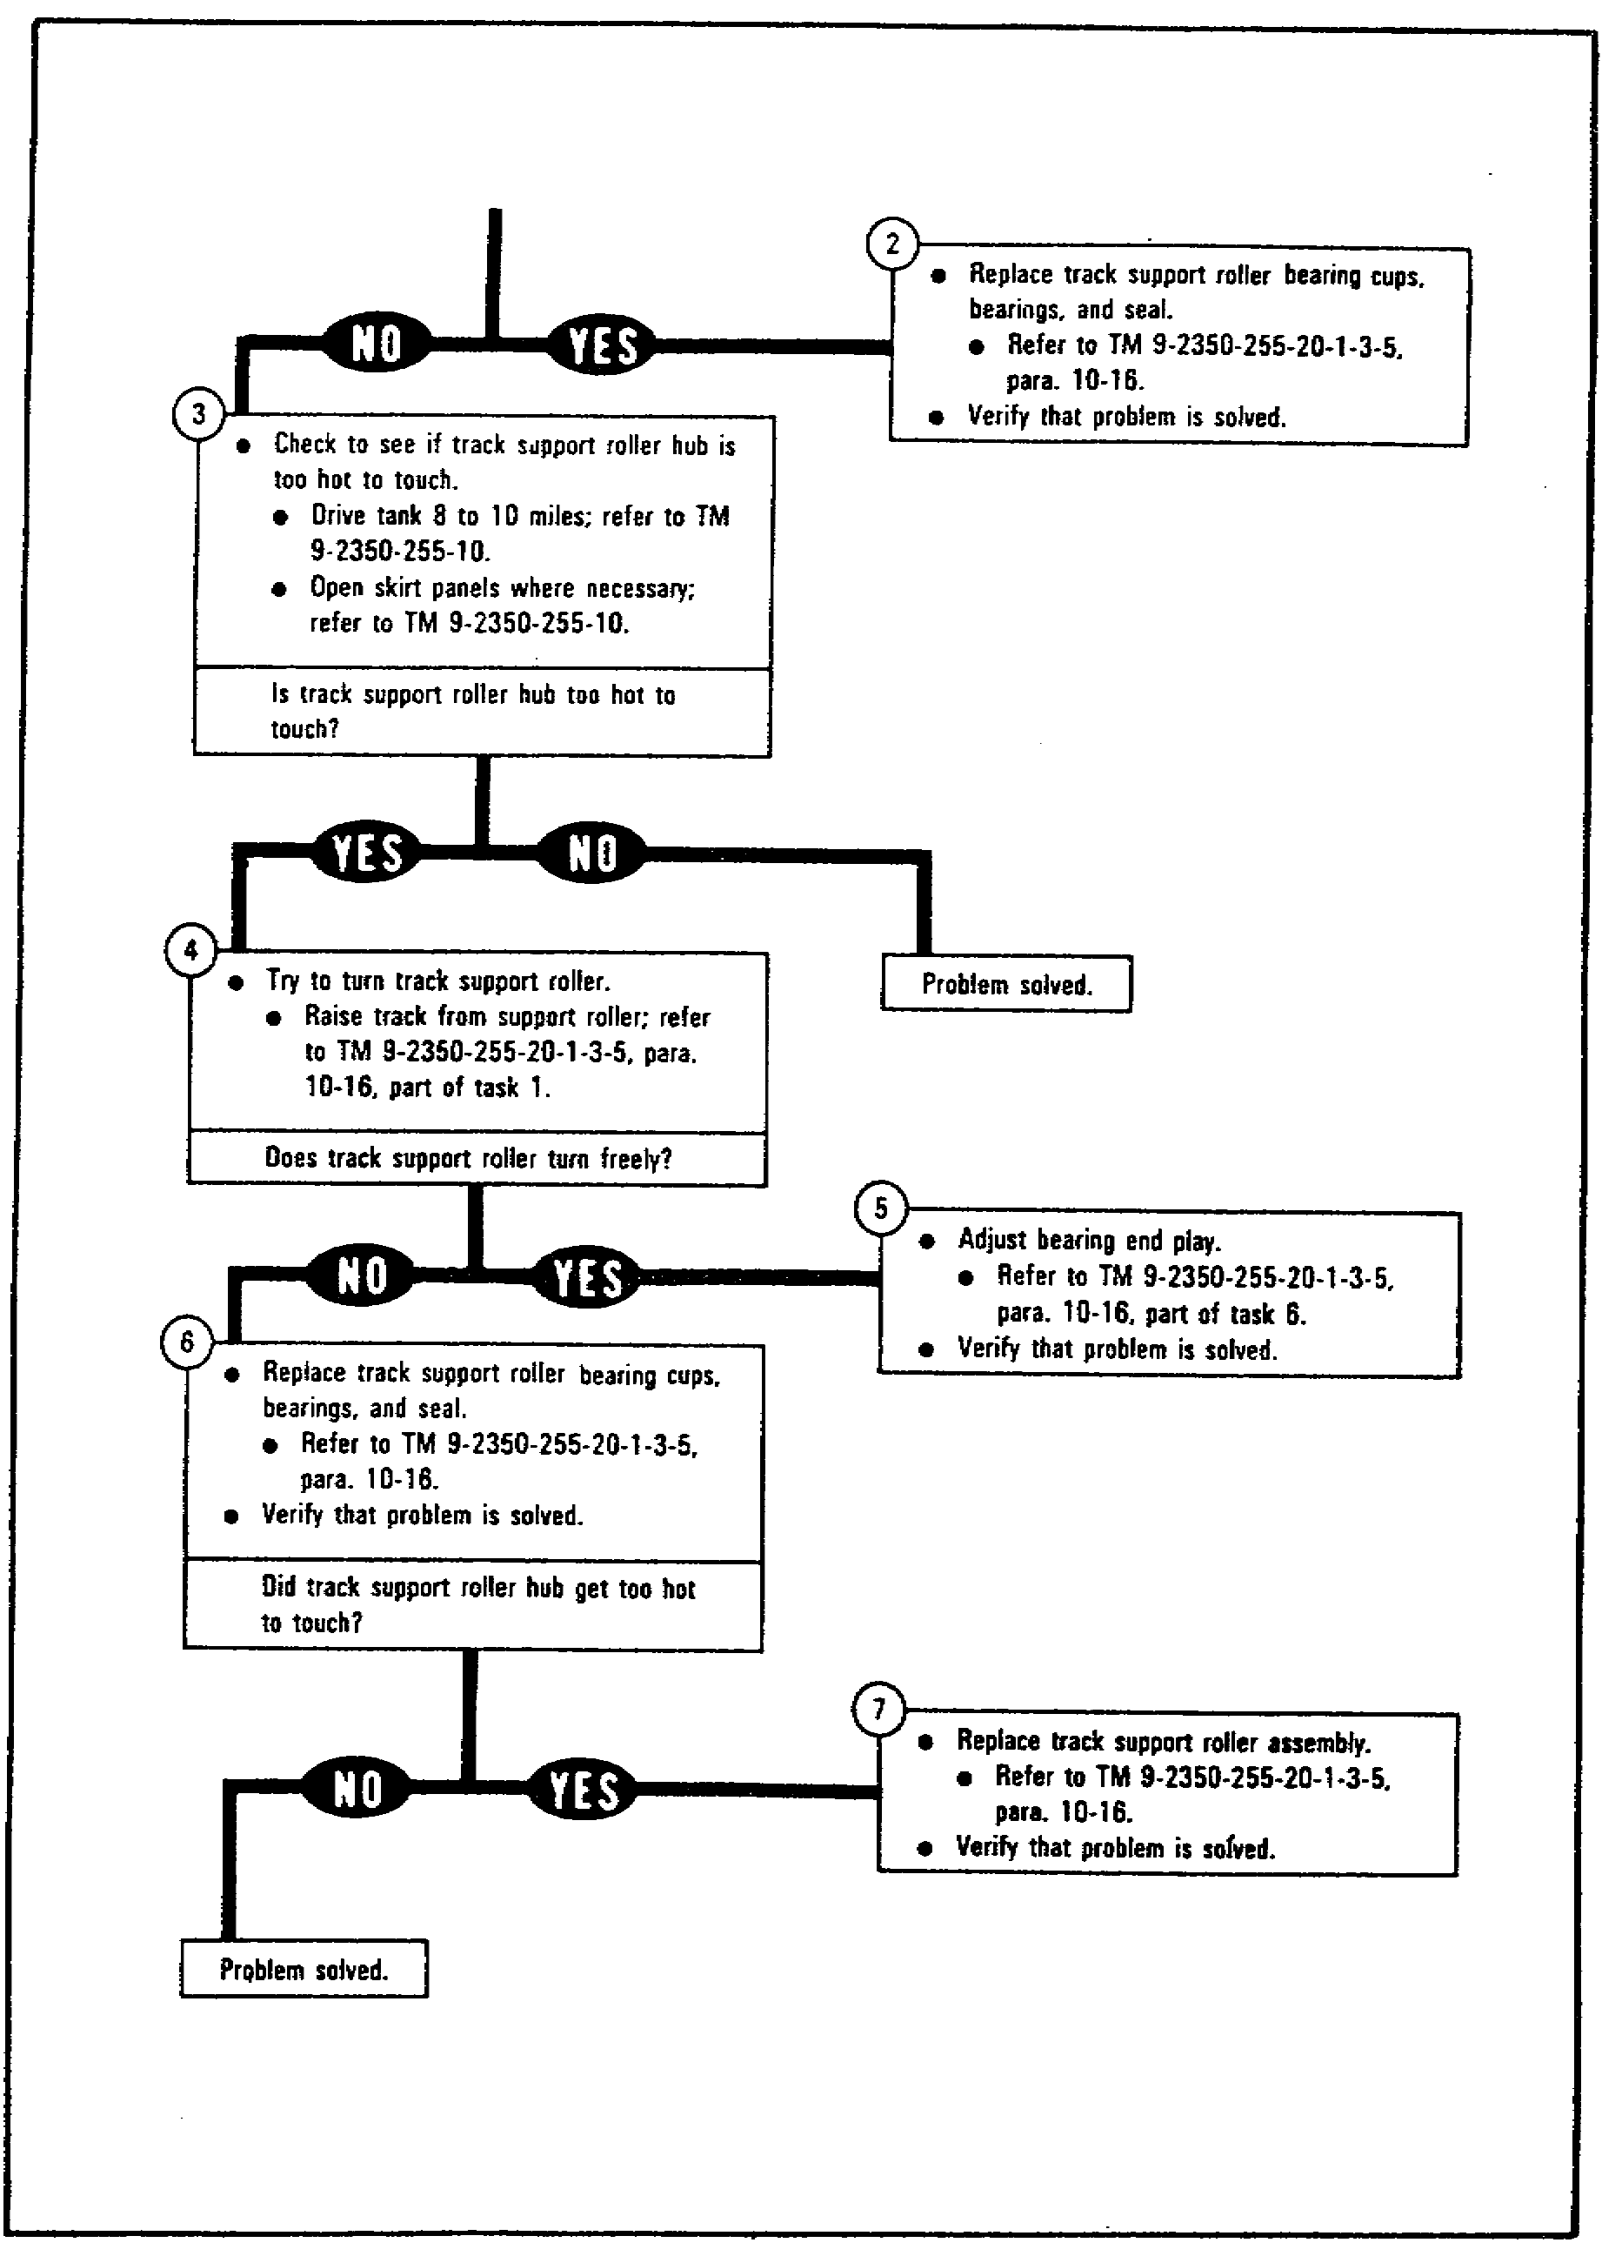
FIGURE 26. TYPICAL PTP FLOW CHART (CONT.).

34
PRIN. & T/S OF SUSPEN. SYS M1 - OD0479 - LESSON 2/TASK 1

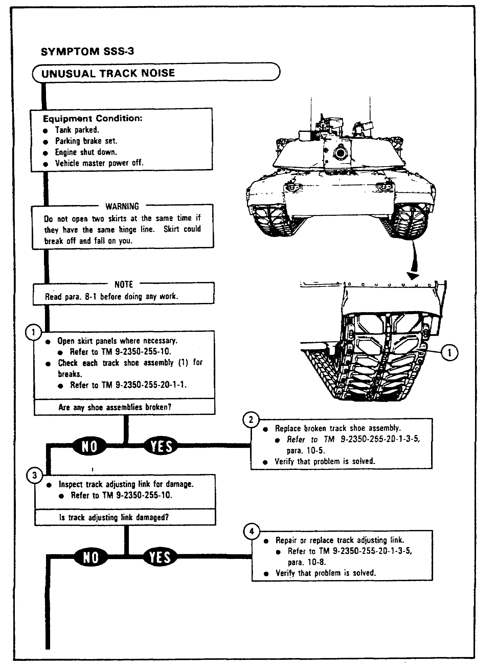
FIGURE 26. TYPICAL PTP FLOW CHART (CONT.)

35
PRIN. & T/S OF SUSPEN. SYS M1 - OD0479 - LESSON 2/TASK 1

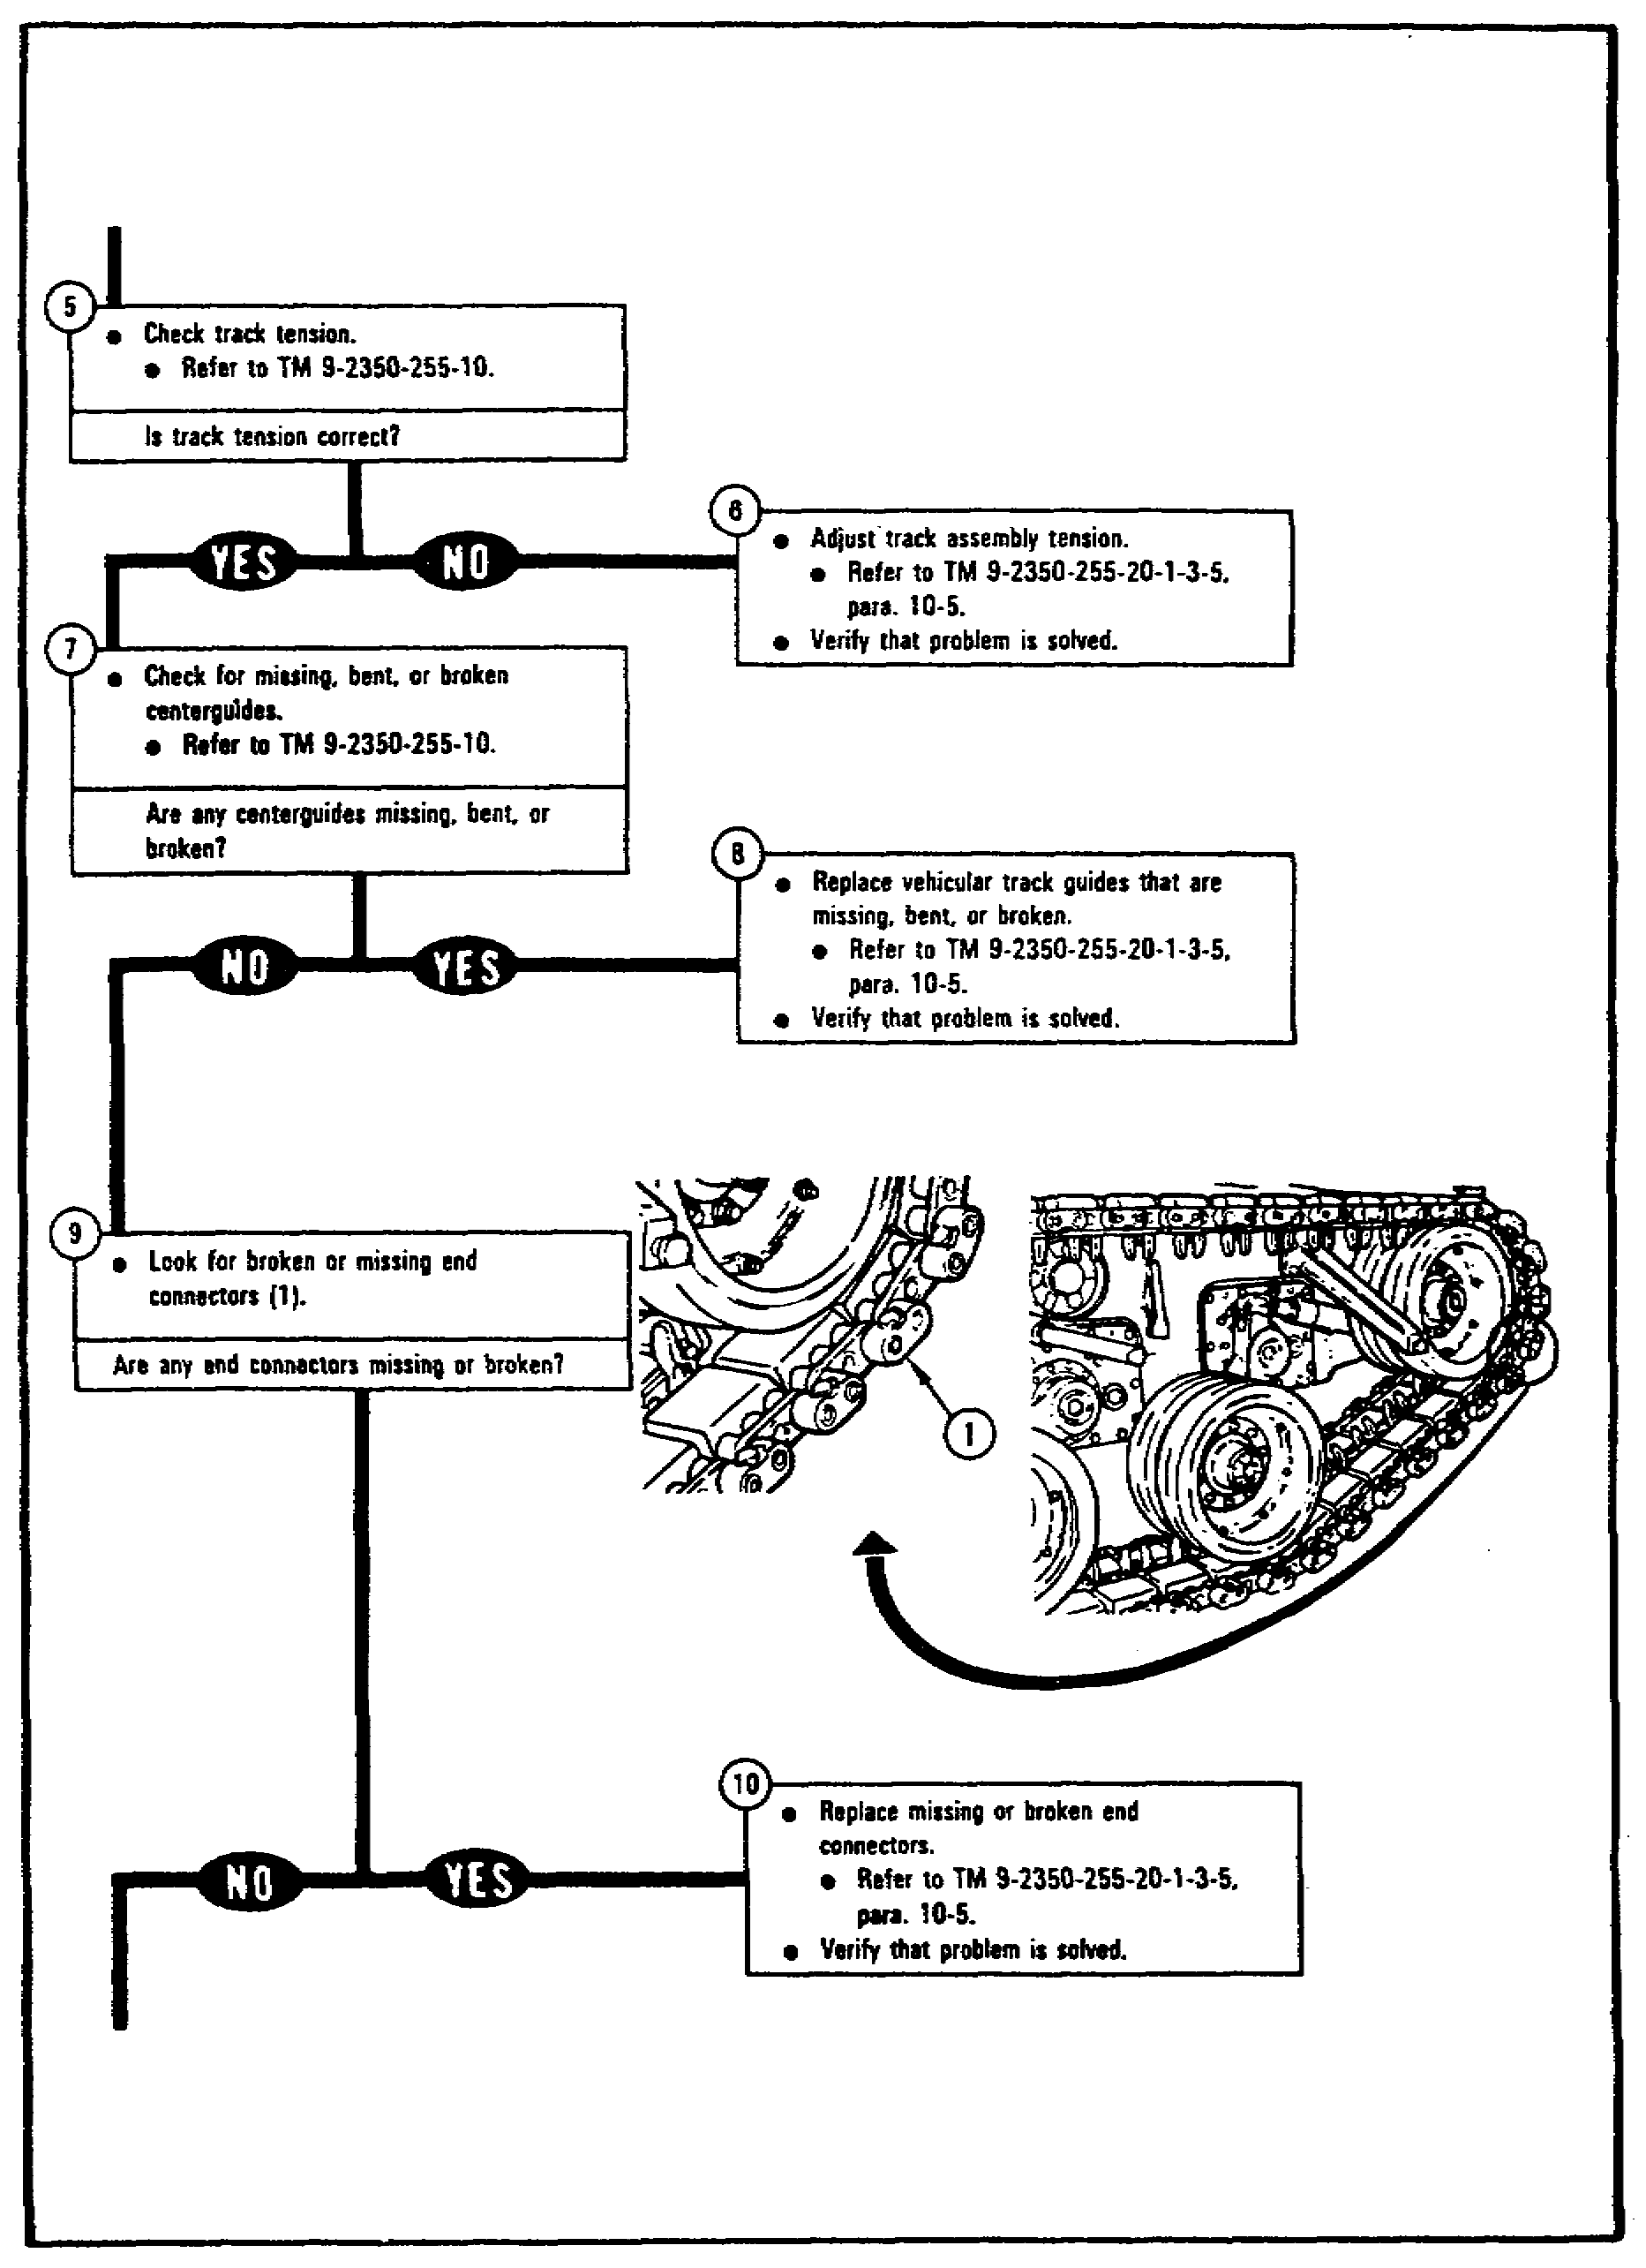
FIGURE 26. TYPICAL PTP FLOW CHART (CONT.)

36
PRIN. & T/S OF SUSPEN. SYS M1 - OD0479 - LESSON 2/TASK 1

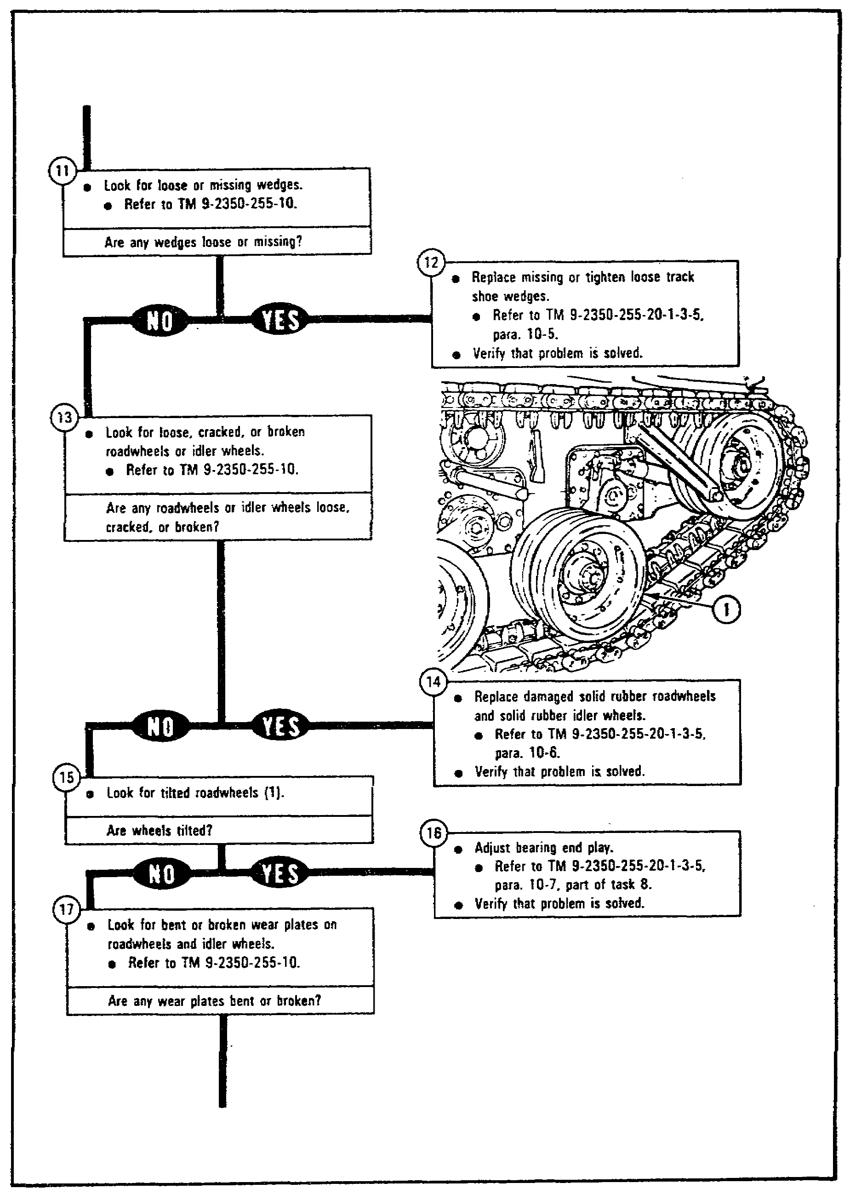
FIGURE 26. TYPICAL PTP FLOW CHART (CONT.)

37
PRIN. & T/S OF SUSPEN. SYS M1 - OD0479 - LESSON 2/TASK 1

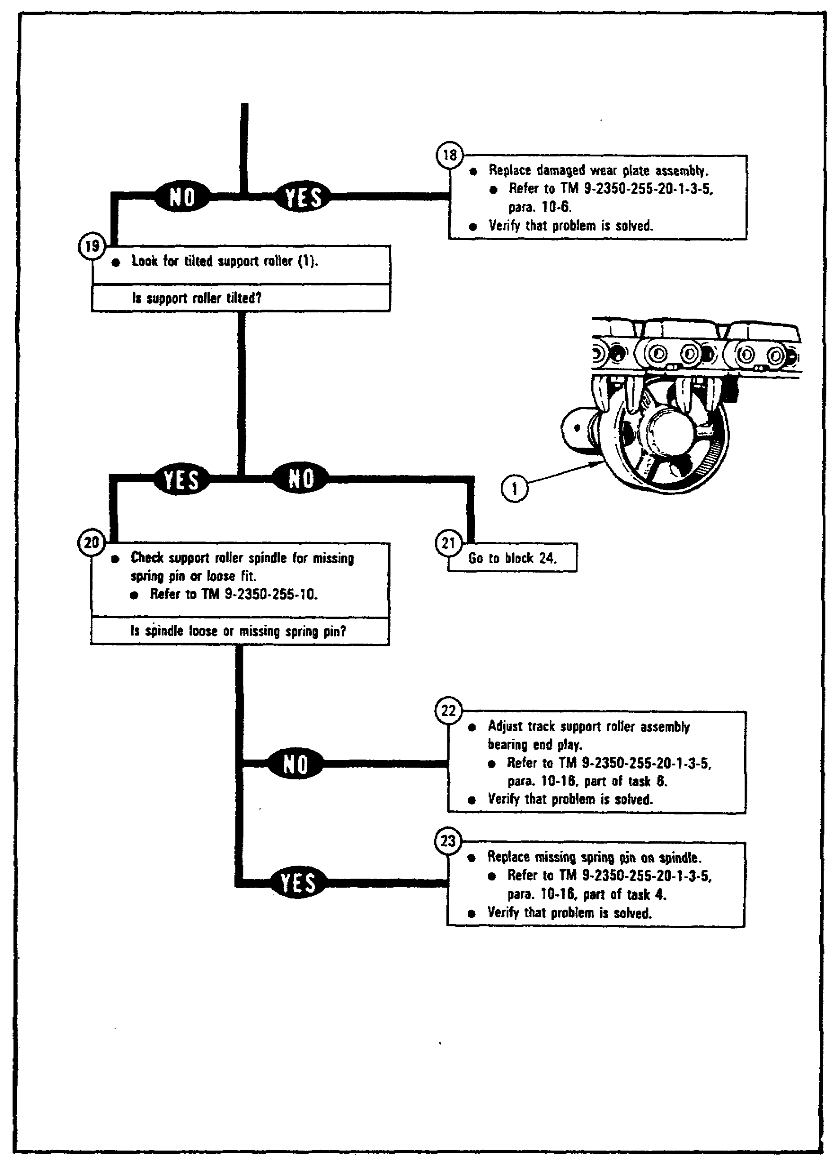
FIGURE 26. TYPICAL PTP FLOW CHART (CONT.)

38
PRIN. & T/S OF SUSPEN. SYS M1 - OD0479 - LESSON 2/TASK 1

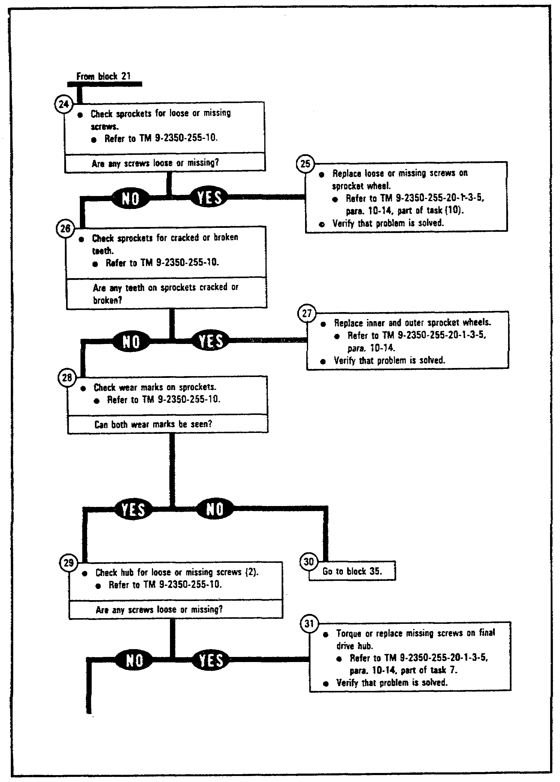
FIGURE 26. TYPICAL PTP FLOW CHART (CONT.)

39
PRIN. & T/S OF SUSPEN. SYS M1 - OD0479 - LESSON 2/TASK 1

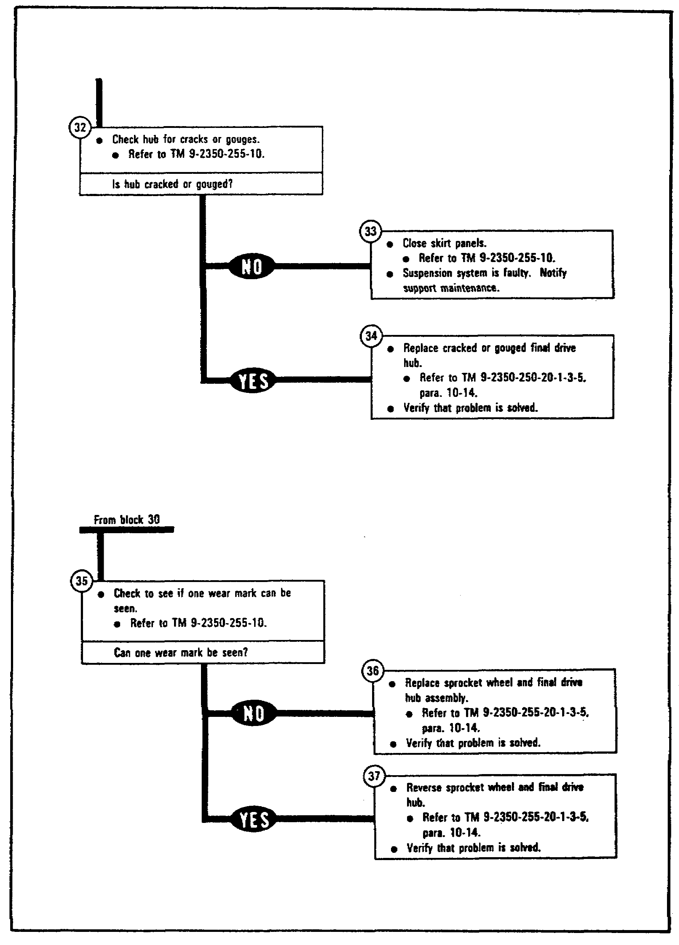
FIGURE 26. TYPICAL PTP FLOW CHART (CONT.)

40
PRIN. & T/S OF SUSPEN. SYS M1 - OD0479 - LESSON 2/TASK 1

The troubleshooting procedures may or may not specify faulty components. While the ATPs almost always will, the PTPs, because most of them depend heavily upon the STE test set, usually do not specify faulty components. That specification usually appears on the set communicator (SETCOM) of the STE.

4. Troubleshooting the M1 Tank Suspension System

a. Support Roller Hub Is Too Hot. This subsection will cover a sample troubleshooting procedure; it will show how the procedures discussed previously are actually used to troubleshoot the M1 suspension system.

To begin, a tank crew brings in an M1 tank and turns in a DA Form 2404 that states the left track on the vehicle seems to be loose. That statement does not describe the malfunction in sufficient detail to begin a troubleshooting procedure, so the mechanic would ask the driver to describe the nature of the noise. In this case, the driver now tells the mechanic that he also noticed smoke coming from the top of the left track.

Given this information the mechanic knows that the problem is in the suspension system. Smoke coming from the top of the track indicates to the mechanic that there is a problem with the support rollers. While checking the support rollers he finds that one of them is extremely hot. He can then consult the Suspension System Fault Symptom Index (table 6 on the following page).

After consulting the Fault Symptom Index the mechanic decides to troubleshoot the symptom SUPPORT ROLLER HUB IS TOO HOT. The fault symptom index directs the mechanic to the correct PTP.

b. Preparing to Troubleshoot. A number of conditions are necessary before troubleshooting can begin on the support roller.

(1) Common Tools. Some troubleshooting tasks require common tools to perform the necessary maintenance. However, this particular task does not require any common tools.

41
PRIN. & T/S OF SUSPEN. SYS M1 - OD0479 - LESSON 2/TASK 1

TABLE 6. SUSPENSION SYSTEM FAULT SYMPTOM INDEX.

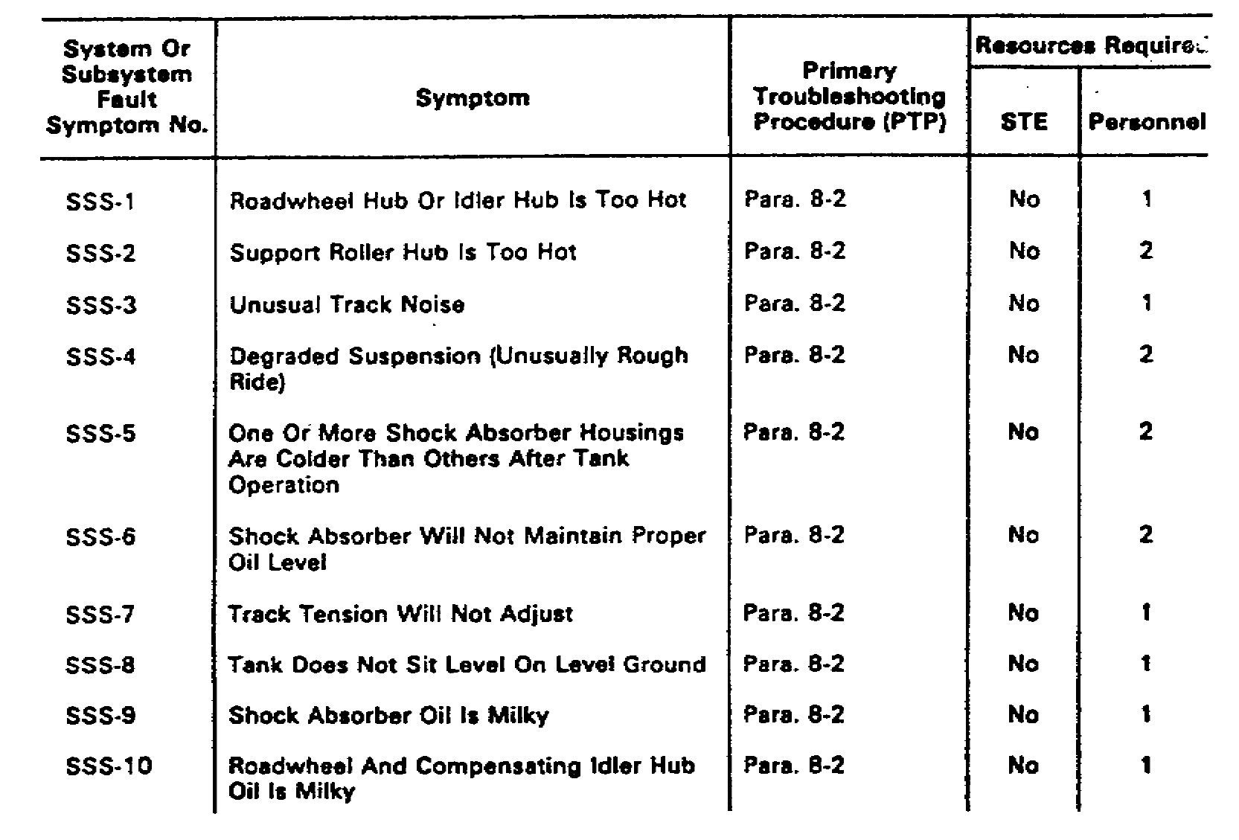

(2) Test Equipment/Special Tools. Test equipment, such as the STE-M1/FVS test set and special tools, are required for some tasks. The suspension system does not require any test equipment, so none are listed in this particular PTP.

(3) Equipment Condition. The following conditions should be met before working on the vehicle:

o The tank should be parked.

o The parking brake should be set.

o The engine should be shut down.

o The vehicle master power should be off.

c. Starting the Troubleshooting Procedure. The steps of the troubleshooting procedure for the support roller hub are as follows:

42
PRIN. & T/S OF SUSPEN. SYS M1 - OD 0479 - LESSON 2/TASK 1

WARNING

Do not touch the hub with bare hands. The hub may be extremely hot and cause severe burns.

Do not open two skirts at the same time if they have the same hinge line. The skirt could break off and cause injury.

(1) The mechanic is directed to ensure that this operator's PMCS actions have been completed.

(2) When the support roller (figure 27) has been lubricated, there will be purged grease (excess grease forced out of the hub) on the support roller hub (1).

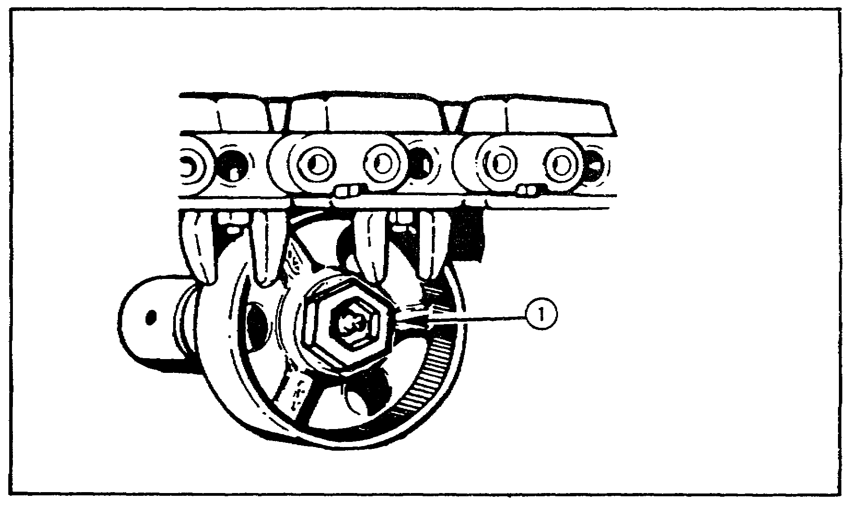
FIGURE 27. SUPPORT ROLLER HUB.

At this time, the purged grease should be checked for metal particles.

(3) For the purpose of this subcourse, assume that no metal particles were found. But if metal particles were found in the purged grease, the mechanic should replace the support roller

43
PRIN. & T/S OF SUSPEN. SYS M1 - OD0479 - LESSON 2/TASK 1

bearing cups, bearings, and seal, and verify that the problem is solved.

(4) Assuming no metal particles were found in the purged grease, the mechanic should drive the tank 8 to 10 miles and then check to see if the track support roller hub is still too hot to touch.

(5) Assuming the track support roller is too hot to touch, the next step is to raise the track from the support roller and try to turn the roller. For the purpose of this subcourse, it does not turn freely. (However, if it had, the bearing end play should be adjusted and the problem should be solved.)

(6) The track support roller does not turn freely, so the next step is to replace the track support roller bearing cups, bearings, and seal, and verify that the problem has been solved.

(7) Again, let's assume that after driving the tank to verify that the problem had been solve, the track support roller hub is still too hot to touch.

(8) The final step in this task is to replace the track support roller assembly and verify that the problem is solved. If the track support roller assembly was correctly installed, the problem is solved.

d. Unusual Track Noise. This procedure will begin at the point where the mechanic has found the fault symptom UNUSUAL TRACK NOISE in the Fault Symptom Index.

e. Preparing to Troubleshoot. The mechanic is directed to ensure that the operator's PMCS actions have been completed.

(1) Common Tools. No common tools are required for this task.

(2) Test Equipment/Special Tools. There are no special tools required for this task.

(3) Equipment Condition. The following conditions should be met before working on the vehicle:

o The tank should be parked.

44
PRIN. & T/S OF SUSPEN. SYS M1 - OD0479 - LESSON 2/TASK 1

o The parking brake should be set.

o The engine should be shut down.

o The vehicle master power should be off.

f. Starting the Troubleshooting Procedure. The steps of the troubleshooting procedure are as follows:

WARNING

Do not open two skirts at the same time if they have the same hinge line. The skirt could break off and cause injury.

(1) The mechanic should open the skirt panels where necessary and check each track shoe assembly (1)(figure 28) for breaks.

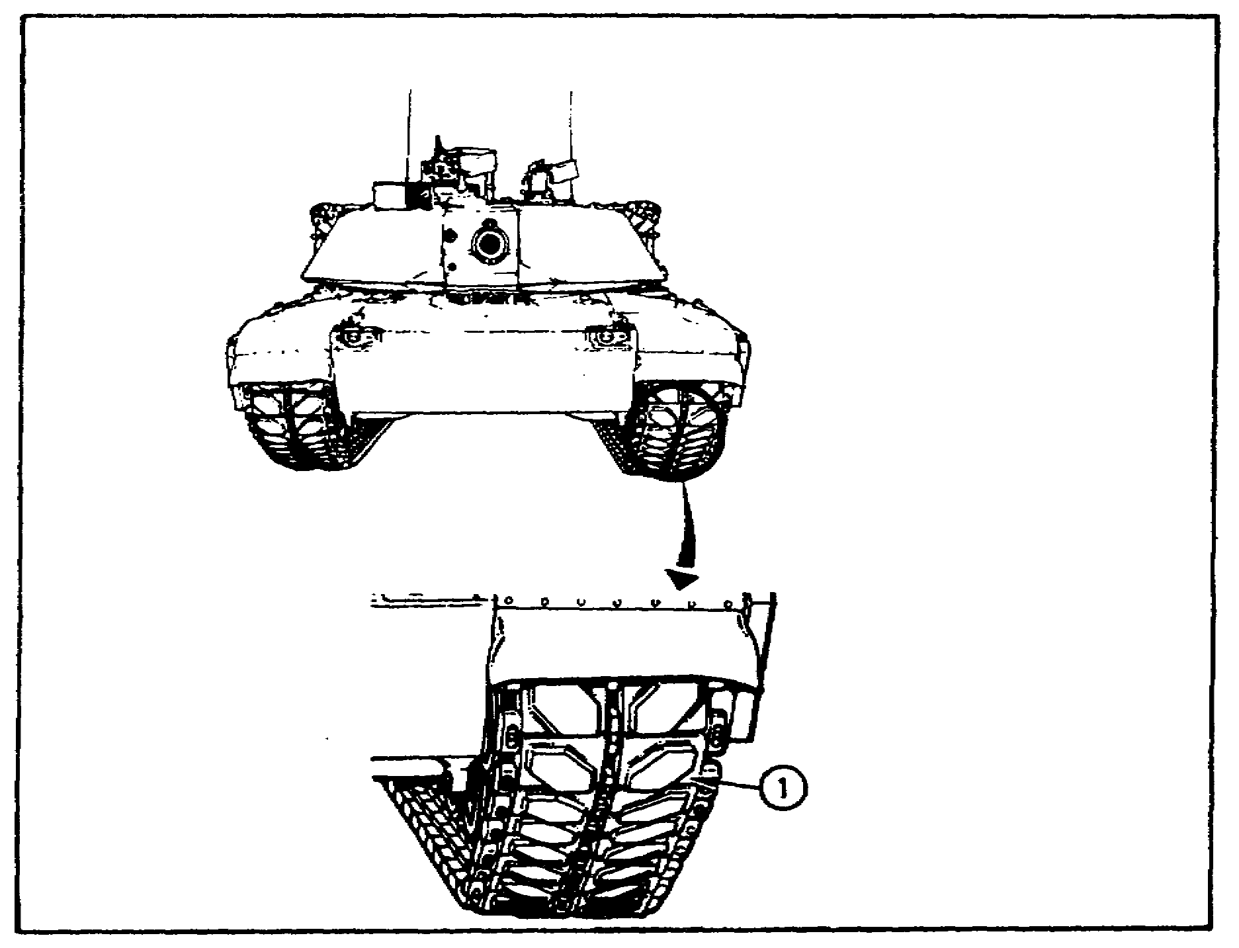
FIGURE 28. TRACK SHOE ASSEMBLY.

45
PRIN. & T/S OF SUSPEN. SYS M1 - OD0479 - LESSON 2/TASK 1

(2) The mechanic found no breaks in the track shoes during his inspection. Had he found broken track shoes, he would have replaced them and verified that the problem was solved.

(3) The next step is to inspect the track adjusting link for damage. In this sample, the track adjusting link is serviceable. Had it been damaged, the mechanic would have replaced it and verified that the problem was solved.

(4) The mechanic then checks the track for proper tension. The tension is correct.

(5) The mechanic should now check for missing, bent, or broken centerguides.

(6) Finding no missing, bent, or broken centerguides, the mechanic should now check for broken or missing end connectors (1)(figure 29).

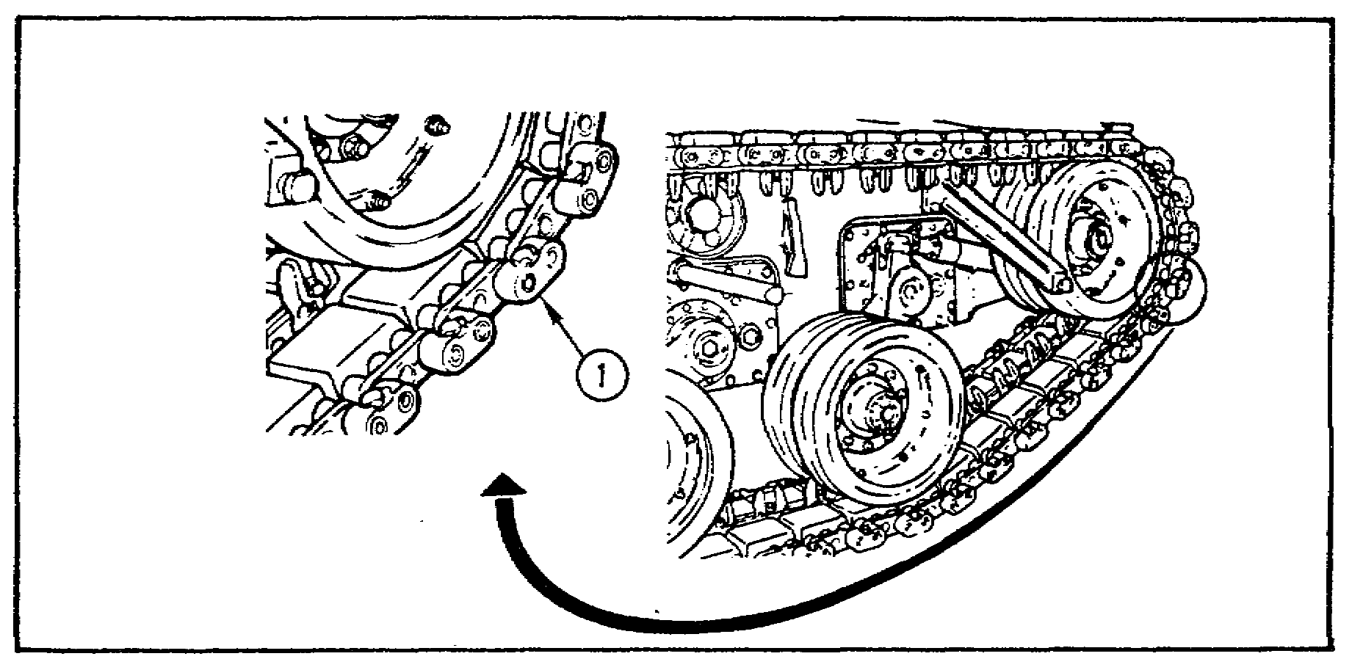
FIGURE 29. TRACK END CONNECTOR.

(7) In this example, no broken or missing end connectors were found. The mechanic should now check for loose or missing track wedges. All track wedges are present and serviceable.

(8) The next step is to look for loose, cracked, or broken roadwheels, or idler wheels. In this case all the roadwheels and idler wheels are serviceable.

46
PRIN. & T/S OF SUSPEN. SYS M1 - OD0479 - LESSON 2/TASK 1

(9) Continuing the troubleshooting procedure, the mechanic should check for tilted roadwheels (leaning to one side).

(10) For the purpose of this subcourse, no tilted road wheels were found. However, if any of the roadwheels were tilted the mechanic should adjust the bearing end play and verify that the problem is solved. Since no roadwheels are tilted the mechanic can now proceed to the next step.

(11) The next step is to look for bent or broken wear plates on the roadwheels and idler wheels.

(12) No wear plates were bent or broken, so the mechanic proceeds to the next step, which is to check for a tilted support roller.

(13) When no tilted support roller is found, the mechanic moves on to the next step, which is to check the sprockets for loose or missing screws.

(14) Finding no missing screws, the mechanic stays with the sprockets, and checks for cracked or broken teeth.

(15) In this example, no teeth are cracked or broken on the sprockets.

(16) The next step is to check the wear marks on the sprockets. The question in the troubleshooting procedure asks if both wear marks can be seen. For the purpose of this subcourse, the answer is yes.

(17) The mechanic continues the troubleshooting procedure by checking the final drive hub for loose or missing screws.

(18) Finding no loose or missing screws on the final drive hub, the mechanic checks the hub for cracks or gouges.

(19) No cracks or gouges were found. At this point the mechanic should close the skirt panel. The suspension system is faulty and cannot be repaired at unit level. He should inform his supervisor so that support maintenance may be notified.

47
PRIN. & T/S OF SUSPEN. SYS M1 - OD0479 - LESSON 2/TASK 1

5. Conclusion

This task showed two situations of troubleshooting the suspension system. These examples were straightforward and did not contain any pathways leading you into different troubleshooting directions. It was done this way in order to take you through an entire logical procedure. As with all troubleshooting, make sure you have all the necessary technical manuals and follow each step in the procedure until the problem is solved.

48
PRIN. & T/S OF SUSPEN. SYS M1 - OD0479 - LESSON 2/PE 2

PRACTICAL EXERCISE 2

On a plain sheet of paper, write down the answer to the following questions. When you have answered them, turn the page and check your answers.

1. What is the master reference table for locating troubleshooting information for a particular functional group?

2. When automated test equipment (ATE) is not available, which troubleshooting procedure is used to troubleshoot a fault symptom?

3. If necessary, the mechanic should operate the tank to help verify the symptom. Before operating the tank, what should he do?

4. When opening the skirts on the M1 tank what precautions should be taken?

5. What conditions should be met before working on the vehicle?

6. When troubleshooting the fault symptom SUPPORT ROLLER HUB IS TOO HOT, if metal particles are found in the purged grease, what is the next step in the troubleshooting procedure?

7. Where, in the technical manual, can the mechanic find the number of personnel required to carry out a troubleshooting procedure?

8. Where, in the technical manual, can the mechanic find step-by-step instructions for finding and correcting a fault?

9. The mechanic should not try to operate the tank if there is any chance the symptom may injure personnel or damage the tank. What is an example of such a symptom?

10. After troubleshooting fault symptom UNUSUAL TRACK NOISE, none of the steps in the procedure corrected the fault; what should the mechanic do?

49
PRIN. & T/S OF SUSPEN. SYS M1 - OD0479 - LESSON 2/PE 2

LESSON 2. PRACTICAL EXERCISE - ANSWERS

1. The troubleshooting index.

2. The alternate troubleshooting procedure.

3. Make sure the surrounding area is clear, to prevent injury to personnel and damage to equipment.

4. Do not open two skirts at the same time if they have the same hinge line.

5. The tank should be parked, the parking brake should be set, the engine should be shut down, and the vehicle master power should be off.

6. The mechanic should replace the support roller bearing cups, bearings and seal.

7. The fault symptom index.

8. The troubleshooting procedure.

9. No steering control.

10. Inform his supervisor to notify support maintenance.

50
PRIN. & T/S OF SUSPEN. SYS M1 - OD0479 - REFERENCES

REFERENCES

61
PRIN. & T/S OF SUSPEN. SYS M1 - OD0479 - REFERENCES

REFERENCES

The following documents were used as resource materials in developing this subcourse:

TM 9-2350-255-10-1
TM 9-2350-255-10-3
TM 9-2350-255-20-1-2-1

52

